|  |
| --- |
| Emma Hodkin |
| UIUX Assignment |
| 202208793 |

# Contents

Contents 1

Table of Figures 3

Part 1 – Cognitive Walkthrough 5

Case Study 1 – Hubble Portal: 5

Case Study 2 – Stack Overflow: 9

Part 2 – Iterative Prototype Design 14

Case Study 1 – Student Mental Health Check-In 14

User Goals 14

Figma Link: 14

General 15

Student submits a report to the app 17

Student requests a meeting with their PS 23

PS reviews a report from a Student 25

PS responds to a meeting request with their Student 29

Case Study 2 – Home Automation app 31

User Goals 31

Figma Link: 31

General 32

The Homeowner toggles lighting/heating 34

The Homeowner can see their overall usage over a given period 42

The Homeowner can use a recommended routine or set one of their own 44

The Homeowner can add to or change their BAS connections. 46

Part 3 – User Flows of Front-End Mock-Ups 48

3.1 – Implemented User Goals 48

User Goals 48

General 48

The User must be able to change the heating/lighting of a given room 49

The User must be able to add/enable a routine 53

The User must be able to track their usage and see suggestions on optimisation 54

The User must be able to activate a peripheral 55

3.2 – Code Overview 56

GitHub Link: 56

Coding Features 56

3.4 – Video Walkthrough: 59

3.5 – Reflection 60

Part 4 – User Testing 61

4.1 – Testing User Goals 61

Tester Goals 61

General 61

1. The Tester should attempt to turn a light on in the Kitchen 62

2. The Tester should attempt to change the temperature in the Study to 18° 63

3. The Tester should attempt to enable a routine 64

4. The Tester should attempt to tick off a suggestion 65

5. The Tester should attempt to activate a peripheral 66

4.2 – Tester Survey 67

Survey Link: 67

4.3 – Reflection 73

Bibliography 74

# Table of Figures

Figure 1 - Hubble home page 6

Figure 2 - Inclusion & Wellbeing page 7

Figure 3 - Wellbeing & Inclusion resources page 8

Figure 4 - Pathways to Support request page 9

Figure 5 - Stack Overflow home page 10

Figure 6 - Computer Science Community page 11

Figure 7 - Computer Science Community page (filtered for Turing-machine questions) 12

Figure 8 - Turing machine question 13

Figure 9 - Colour Scheme for the Student Mental Health App 16

Figure 10 - Student side of High-Level Prototype in Figma 17

Figure 11 - Staff side of High-Level Prototype 17

Figure 12 - Log In Page 18

Figure 13 - Student Menu Page 19

Figure 14 - Check-In Page 20

Figure 15 - Login Page for Mental Health App 21

Figure 16 - Student Menu Page 22

Figure 17 - Check-In page 23

Figure 18 - Meeting Request page 24

Figure 19 - Student Meeting Request page 25

Figure 20 - Staff Menu page 26

Figure 21 - Student Check-In Review page 27

Figure 22 - Popup for Student Check-In Review page 27

Figure 23 - Staff Menu Page 28

Figure 24 - Staff Menu page, on Hover 29

Figure 25 - Check In Review page 29

Figure 26 - Meeting Request Review page 30

Figure 27 - Popup for Meeting Request Review page 30

Figure 28 - Student Meeting Request page 31

Figure 29 - Colour palette for the BAS webapp 33

Figure 30 - Full view of each Figma page in the High-Level Prototype 34

Figure 31 - Log In page 35

Figure 32 - Menu page 36

Figure 33 - Lighting Settings page 37

Figure 34 - Lighting Settings page Popup 37

Figure 35 - Heating Settings page 38

Figure 36 – Log In Page 39

Figure 37 – Menu Page 40

Figure 38 – Menu Page – Highlighted button 40

Figure 39 – Lighting Settings page 41

Figure 40 – Lighting page Popup menu 41

Figure 41 – Heating Settings page 42

Figure 42 - User History page 43

Figure 43 – User History page 44

Figure 44 - Routines page 45

Figure 45 - Routines page Popup 45

Figure 46 - Routines page 46

Figure 47 - Routines page, popup 46

Figure 48 - Connections page 47

Figure 49 - Connections page 48

Figure 50 - Log In page 50

Figure 51 - Incorrect credentials error message 50

Figure 52 - Central Menu page 51

Figure 53 - Lighting Control page 52

Figure 54 - Lighting Control page Popup 52

Figure 55 - Temperature Controls page 53

Figure 56 - Routines page 54

Figure 57 - Routines page Popup 54

Figure 58 - User History page 55

Figure 59 - Connections page 56

Figure 60 - HTML code of Lighting toggle 57

Figure 61 - CSS code of Toggle Animation 57

Figure 62 - HTML for Routines Overlay 58

Figure 63 - JavaScript for the Overlay methods 58

Figure 64 - CSS for Overlay methods 59

Figure 65 - User flow of Test 1 63

Figure 66 - User flow of Test 2 64

Figure 67 - User flow for Test 3 65

Figure 68 - User flow for Test 4 66

Figure 69 - User flow of Task 5 67

Figure 70 - Survey Response 1 68

Figure 71 - Survey Response 2 68

Figure 72 - Survey Response 3 69

Figure 73 - Survey Response 4 69

Figure 74 - Survey Response 5 70

Figure 75 - Survey Response 6 70

Figure 76 - Survey Response 7 71

Figure 77 - Survey Response 8 71

Figure 78 - Survey Response 9 72

Figure 79 - Survey Response 10 72

Figure 80 - Survey Response 11 72

Figure 81 - Survey Response 12 73

# Part 1 – Cognitive Walkthrough

## Case Study 1 – Hubble Portal:

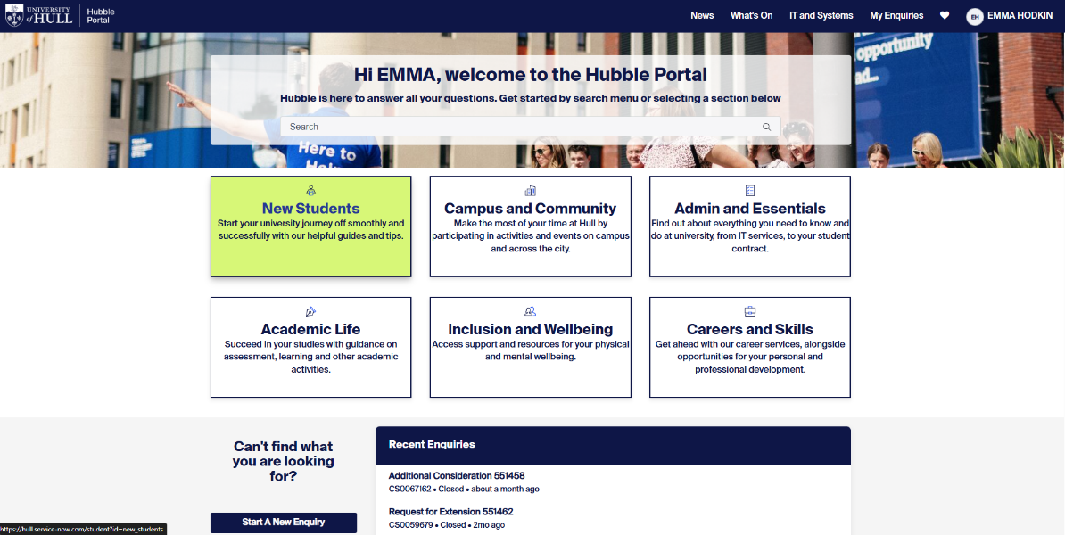

Very clear indication of which box is being selected. This conforms with Nielsen’s first heuristic, that of visibility of system status (Gonzalez-Holland et al., 2017)

Clearly labelling and expanding upon the box titles gives affordances to the user so they can understand each action at a glance (*Don Norman’s Principles of Interaction Design | by Sachin Rekhi | Medium*, 2017)

Figure 1 - Hubble home page

Goal: Find the Mental Health Support page.

Step 1: Access the “Inclusion and Wellbeing” page

* Q: Is the page visible?
* A: Yes, everything loaded very quickly
* Q: Would you know where to go without being told?
* A: Yes, the box is clearly labelled and has a subtitle to guide me to the right area.
* Q: Is there any visual feedback on progressing to the next page?
* A: Yes, the box changes colour when hovered over and the new page loads quickly.

Step 2: Access the “Wellbeing & Inclusion” page

Figure 2 - Inclusion & Wellbeing page

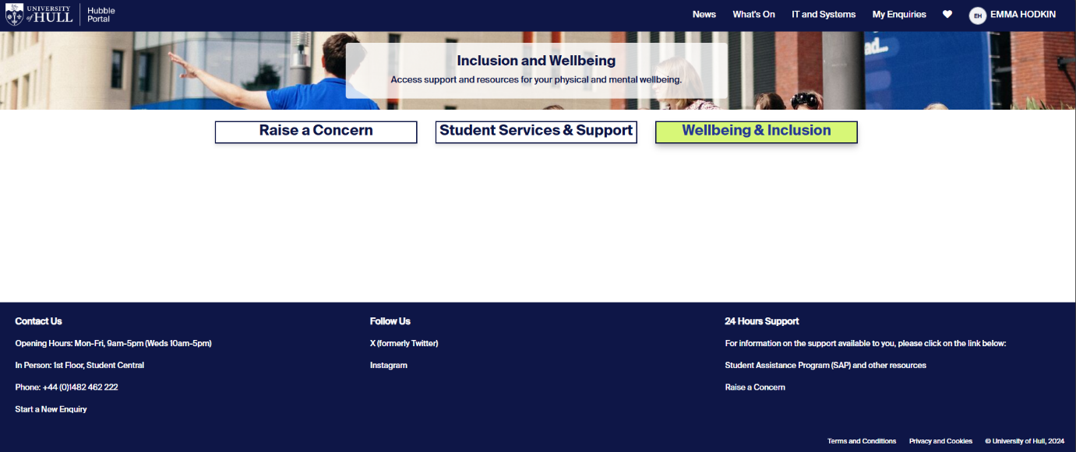

Unlike the previous page, the design is now more minimalist, but instead of this reducing confusion, there is now so little information that we don’t know where to go. This conflicts with Nielsen’s heuristic: Aesthetic and minimalist design. (Gonzalez-Holland et al., 2017)

This page has no visible back or “exit” method, making the user feel trapped in their choices. This goes against Nielsen’s heuristic of User Control and Freedom, where the user should feel free to explore the webpage without fear of constraints. (Gonzalez-Holland et al., 2017)

* Q: Does the page load correctly?
* A: Yes, although the page has no explanations or shows what each function does.
* Q: Would you know where to go without being told?
* A: No, there are two other options I would consider as there are no signposts.
* Q: Is there any visual feedback on progressing to the next page?
* A: Yes, the box changes colour when hovered over and the new page loads quickly.

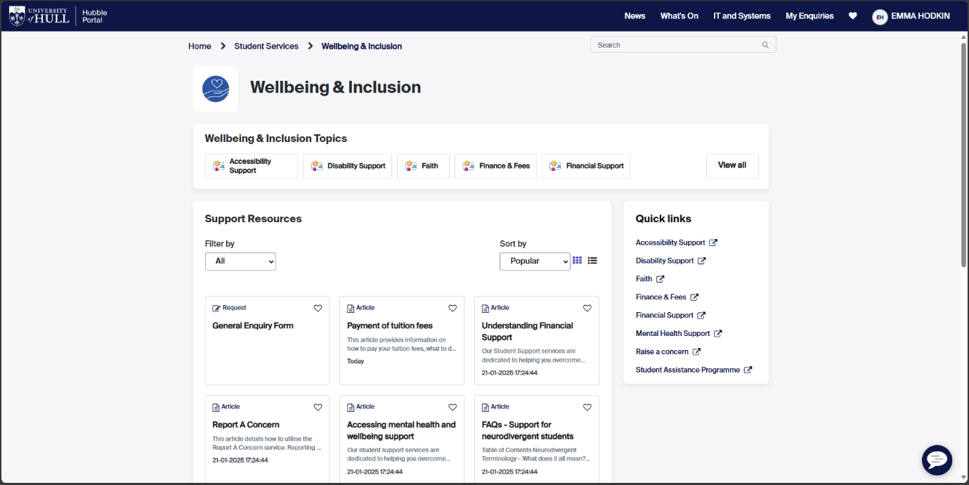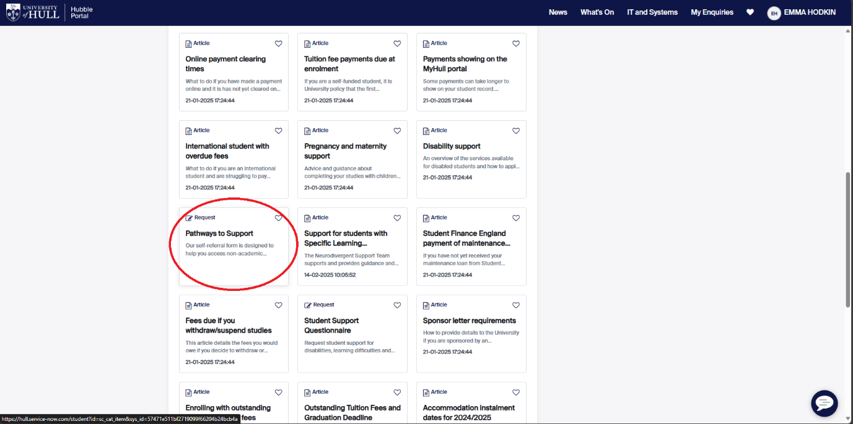

Despite the overall UI change between pages, the consistency of the box method of tabs makes the user feel like they’re still on a continuous website. This follows on from the heuristic of Consistency and Standards. (Gonzalez-Holland et al., 2017)

As all the articles are tightly packed, it makes them harder to see, this contradicts Norman and Nielsen’s ideas of Visibility and Minimalism. (*Don Norman’s Principles of Interaction Design | by Sachin Rekhi | Medium*, 2017), (Gonzalez-Holland et al., 2017)

Figure 3 - Wellbeing & Inclusion resources page

Step 3: Access the “Pathways to support” article

* Q: Is the article easy to find?
* A: Not really, the boxes are small and there are many of them.
* Q: Would you know where to go without being told?
* A: yes, but only after a lot of looking.
* Q: Is there any visual feedback on progressing to the next page?
* A: No, the box doesn’t change when hovered over.

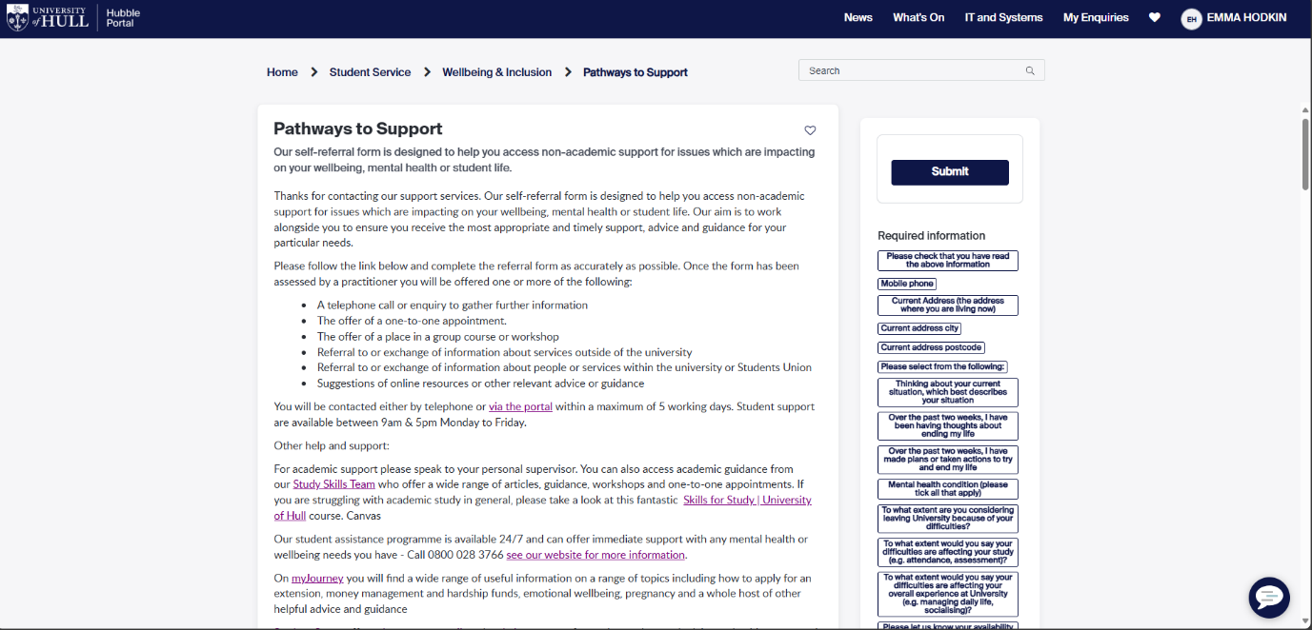

The page uses a blog post format to match between the system and the real world. (Gonzalez-Holland et al., 2017)

On the right there are “required field” boxes which correlate to the form at the bottom of the article, but each box is a different size, which breaks the Consistency rule. (*Don Norman’s Principles of Interaction Design | by Sachin Rekhi | Medium*, 2017)

Figure 4 - Pathways to Support request page

Step 4: Discover Mental Health Support page. (End State)

* Q: Was the article easy to find?
* A: Not really, there were many unlabelled or confusing options that would have taken me a while to get around before I found this page.
* Q: Would you know where to go without being told?
* A: Yes, but only after a lot of looking.
* Q: Was there any visual feedback on progressing through these steps?
* A: Sometimes, at the start the boxes would be labelled and change colour when hovered over, but other times it wasn’t.

## Case Study 2 – Stack Overflow:

Figure 5 - Stack Overflow home page

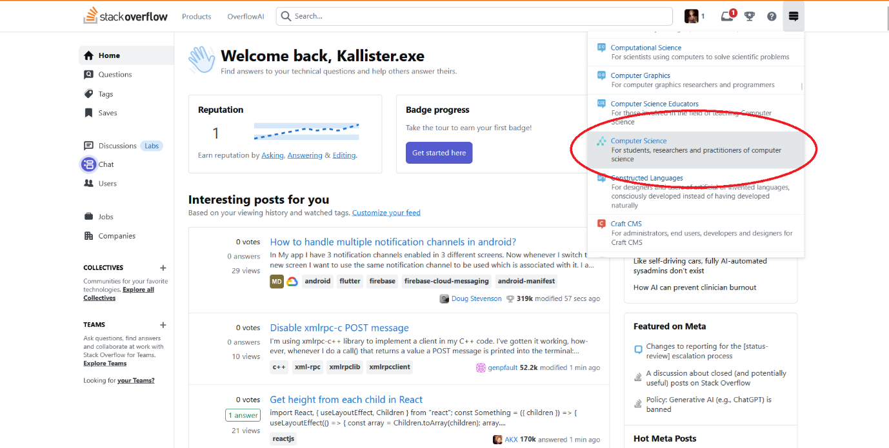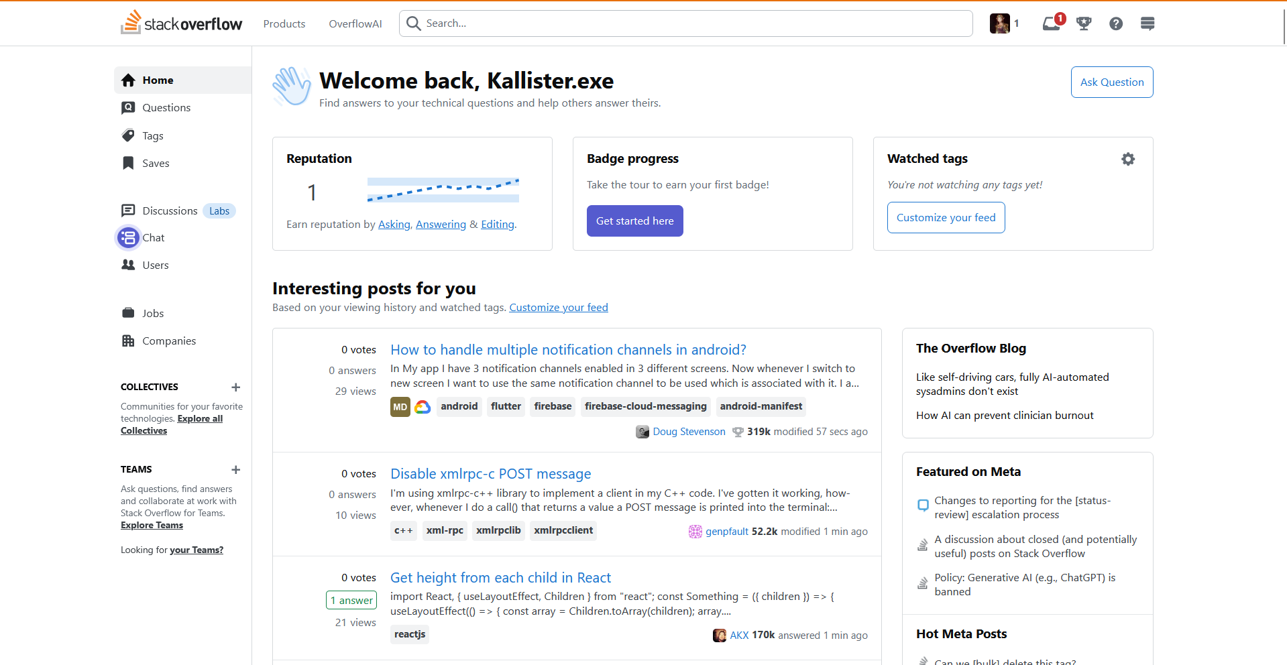

The UI of this webpage is very cluttered, with many metrics and features within view. The community tab is very small and not labelled with no discernible use. This opposes the minimalist idea put forward by both Neilsen and Norman. (Gonzalez-Holland et al., 2017), (*Don Norman’s Principles of Interaction Design | by Sachin Rekhi | Medium*, 2017)

The computer science tab is clearly highlighted when hovered over, given the user direct feedback of their actions as described by Don Norman. (*Don Norman’s Principles of Interaction Design | by Sachin Rekhi | Medium*, 2017)

Goal: Find a Turing Machine problem to help with.

Step 1: Access the “Computer Science” page from the stack exchange tab

* Q: Is the tab visible?
* A: Yes, but it’s not labelled and has no explanation.
* Q: Would you know where to go without being told?
* A: No, the page is very busy, and I wouldn’t know to use a small unlabelled tab.
* Q: Is there any visual feedback on progressing to the next page?
* A: Yes, the box changes colour when hovered over and the new page loads quickly.

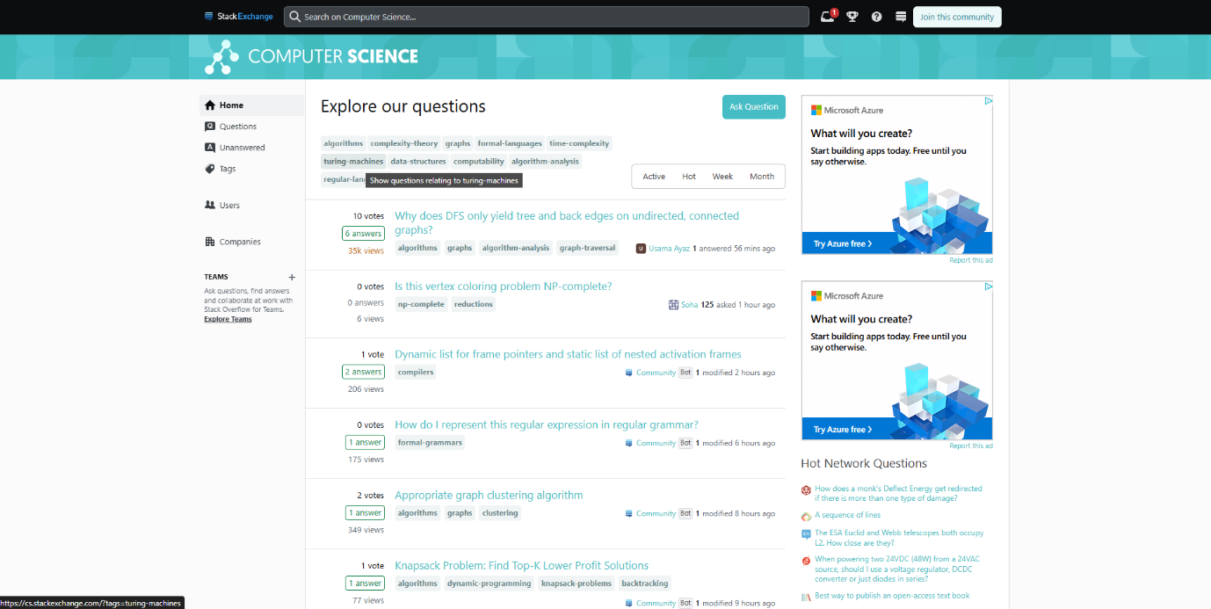

The page has a lot of options to filter a user’s search, from time to tags, the user has a lot of methods to tailor their experience. The user can also search for their question at the top, giving the user flexibility. (Gonzalez-Holland et al., 2017)

The UI is very cohesive on this page as it has a consistent colour scheme and the standard list of links for each question. (*Don Norman’s Principles of Interaction Design | by Sachin Rekhi | Medium*, 2017)

Figure 6 - Computer Science Community page

Step 2: Access the “Turing Machines” page from the questions list

* Q: Is the tab visible?
* A: Yes, but it’s not labelled and has no explanation.
* Q: Would you know where to go without being told?
* A: No, the page is very busy, and I wouldn’t know to use a small unlabelled tab.
* Q: Is there any visual feedback on progressing to the next page?
* A: Yes, the box changes colour when hovered over and the new page loads quickly.

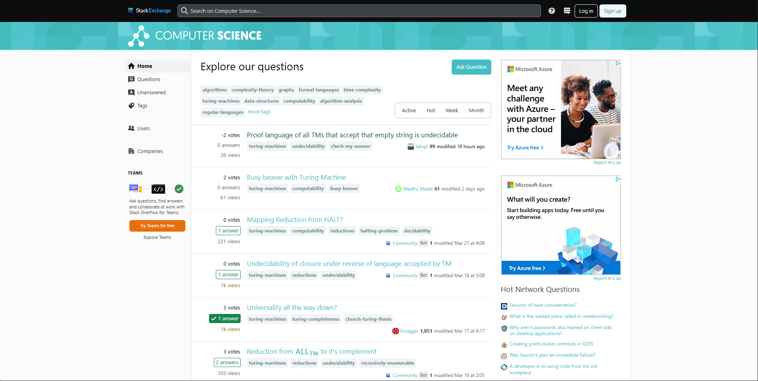

The link colour has changed after being clicked on, allowing the user to quickly identify which questions they have already viewed. This visual feedback removes the need to remember which questions have been seen, as described by Nielsen. (Gonzalez-Holland et al., 2017), (*Don Norman’s Principles of Interaction Design | by Sachin Rekhi | Medium*, 2017)

Like the previous case study, the website itself has no means of backtracking or exit functions, leaving the user locked into their choices. (Gonzalez-Holland et al., 2017)

Figure 7 - Computer Science Community page (filtered for Turing-machine questions)

Step 3: Access a question from the list

* Q: Is the question button visible?
* A: Yes, each question has a hyperlink and is coloured differently.
* Q: Would you know where to go without being told?
* A: Yes, once you have selected a question type, they are the only ones listed.
* Q: Is there any visual feedback on progressing to the next page?
* A: Yes, the hyperlink changes colour when hovered over and the new page loads quickly. The link also stays a new colour once clicked so if you navigate back, you know which questions you have viewed.

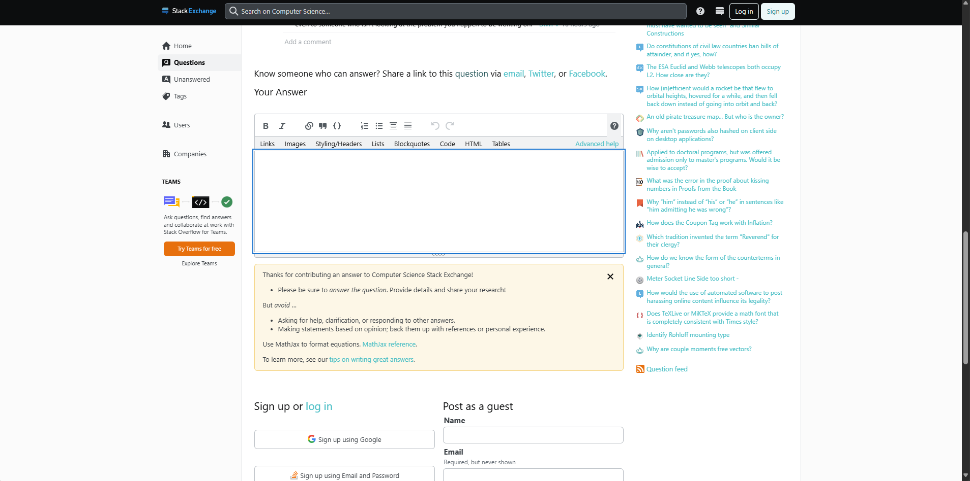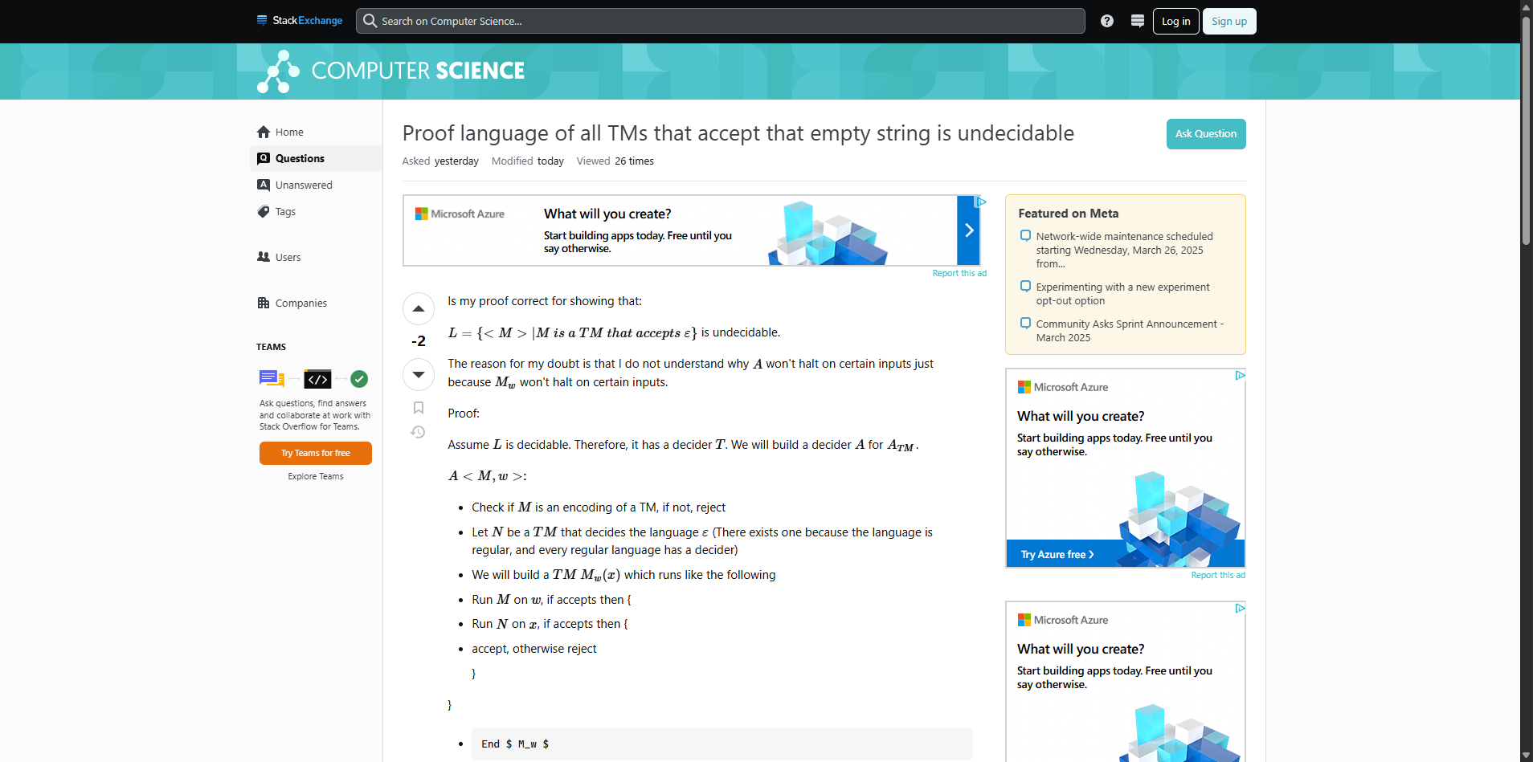

While the text box for answers is clearly visibly, the user has to scroll down past a warning and a request to log in before they see the submit button, which removes the easy mapping of the button and may confuse the user, antithetical to the mapping guidance given by Don Norman. (*Don Norman’s Principles of Interaction Design | by Sachin Rekhi | Medium*, 2017)

Figure 8 - Turing machine question

Step 4: View and answer the question (End State)

* Q: Is the submit answer button visible?
* A: Yes, each question has a hyperlink and is coloured differently.
* Q: Would you know where to go without being told?
* A: Not really, the answer sections is at the bottom of the question but the submit button is hidden under the sign-up/log-in section, so you’d have to scroll down to click it.
* Q: Is there any visual feedback on progressing to the next page?
* A: Yes, the submit button changes when hovered and gets smaller to mimic a real button press.

# Part 2 – Iterative Prototype Design

## Case Study 1 – Student Mental Health Check-In

### User Goals

Users:

* The Student
* The Personal Supervisor (PS)

User Goals:

* That a Student must be able to report any issues to the webapp easily.
* That a Student should be offered links and videos on improving mental health in the webapp.
* That a PS must be able to see all of the student reports allocated to that PS.
* That a PS should be able to arrange meetings with a Student either on-campus or via Teams.

Expansion:

Students may find it difficult to discuss mental health issues with their PS’s face-to-face as they may not yet have a good rapport with them. Allowing students a way to self-report any issues without direct contact would provide a way of expressing their needs less stressfully. Students also have busy schedules, with their university timetable, social commitments, and potentially a work rota, it is difficult to allocate time for PS meetings. The webapp could allow students to connect with their PS’s more effectively and arrange meetings around their busy schedules.

Personal Supervisors share many of the same issues as students, both with difficulty communicating and hectic diaries. As a PS, they can only work off of information they have, so being able to access all their allocated students’ submissions and overall health check-ins, they can at a glance know if one of their students is in need of extra help. PS’s also have busy schedules, between teaching hours and adult lives, many lecturers may not have a free hour in the day. By using the webapp to communicate between themselves and the student, they can better find a time to discuss any issues with synced calendars and the option for online or offline meetings.

### Figma Link:

<https://www.figma.com/design/gNeYt2FofNReQdEbpW2f53/UIUX---Student-App?t=CVQDNIwcFgDJMuwI-1>

### General

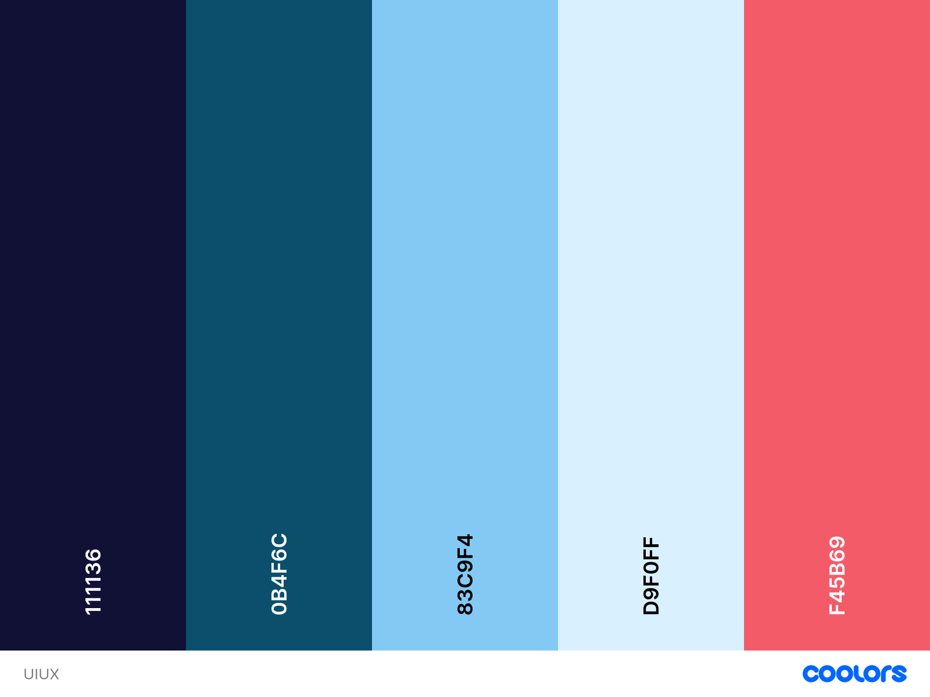

Figure 9 - Colour Scheme for the Student Mental Health App

The colour scheme was chosen due to the associations of blue and the medical industry, especially the NHS as the app is oriented towards mental health. The colour blue is also known to have a calming effect which would be beneficial to students using the app (*How the Color Blue Impacts Moods, Feelings, and Behaviors*, 2024). The desaturated red is the contrast colour and will be used to highlight certain areas and as an accessibility aid for those with colour-blindness or other visual impairments.

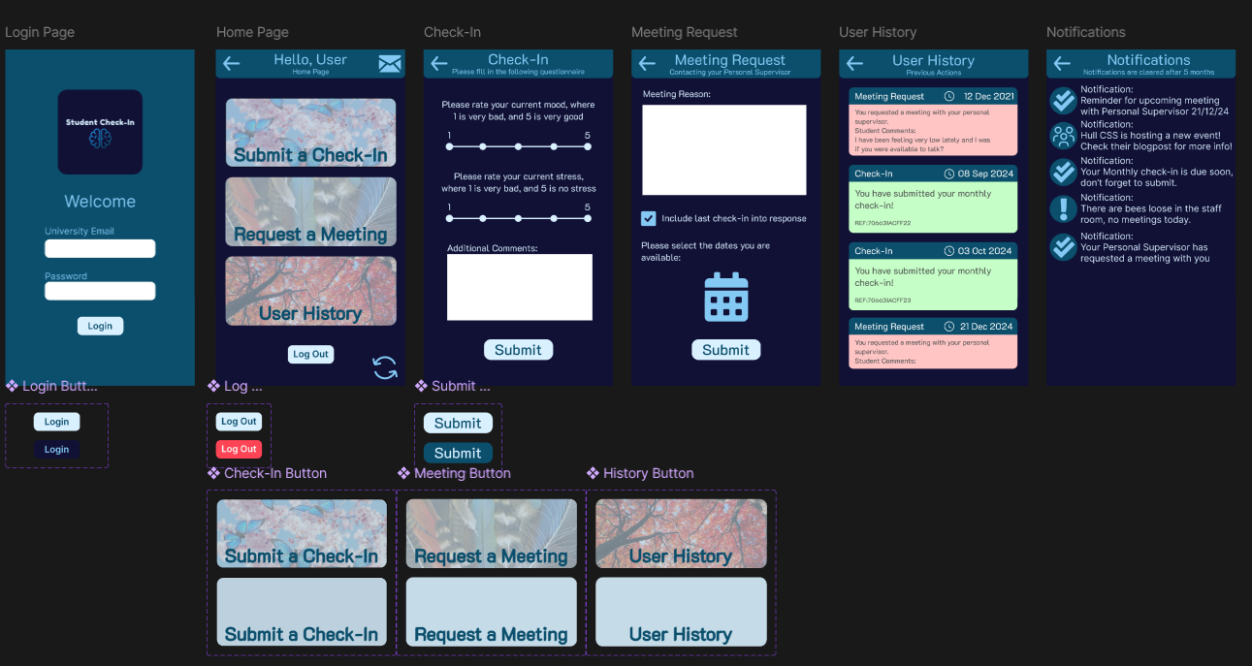

Figure 10 - Student side of High-Level Prototype in Figma

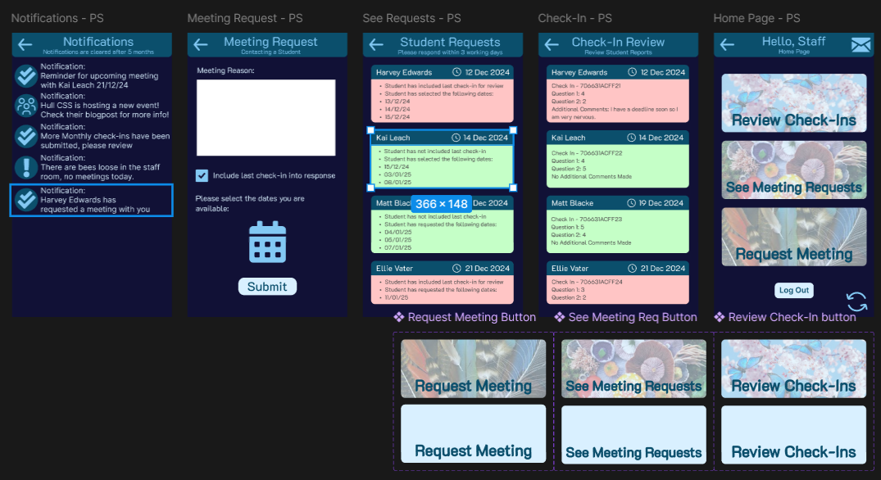

Figure 11 - Staff side of High-Level Prototype

### Student submits a report to the app

#### Low Fidelity

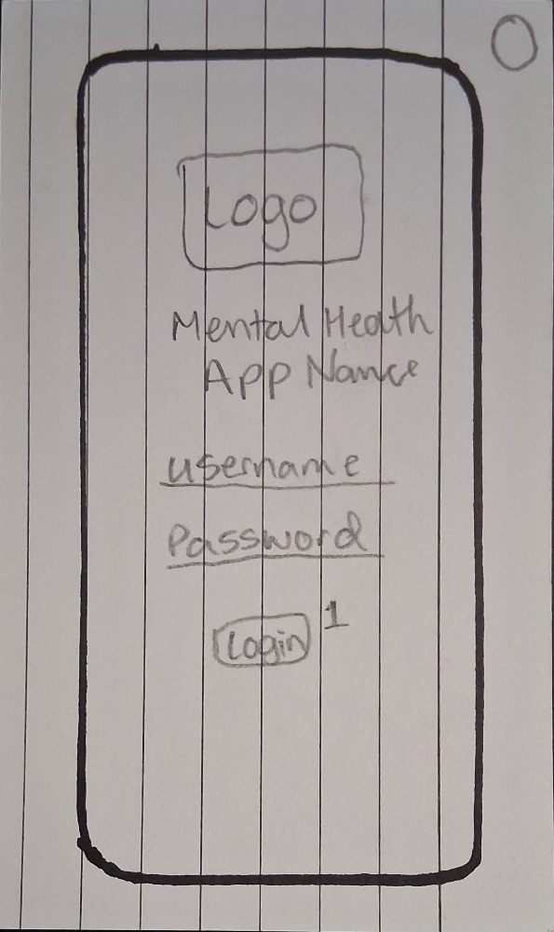

Figure 12 - Log In Page

Step 1: Log into the app

The log in page contains the app logo, the app name, user inputs for the username and password, and the log-in button. Keeping the log in page simple and streamlining the log in process for new users maintains the heuristic of error prevention (Gonzalez-Holland et al., 2017).

Once the user logs in they are directed to the menu page.

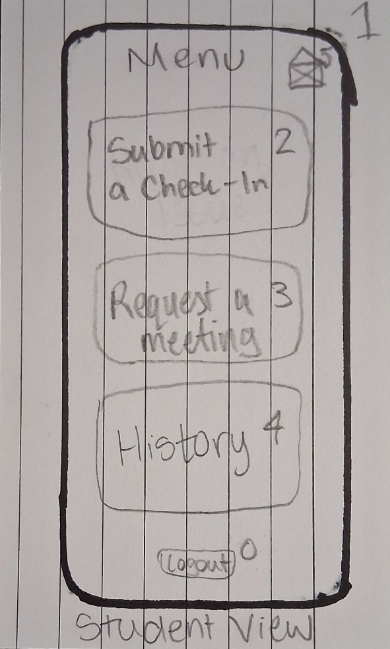

Figure 13 - Student Menu Page

Step 2: Access the Submit a Check-In page

Once the user has logged in as a student, the user can access the check-in page through a large tile button. The menu is simple and provides instant recognition for users due to the clear labelling. There are 3 tiles as well as a notification hub in the top right corner. The mail icon used was chosen to signify the notifications as a real-world connection of receiving information (Gonzalez-Holland et al., 2017) .

Once the user has clicked on the “Submit a Check-In” button they are sent to the Check-In page.

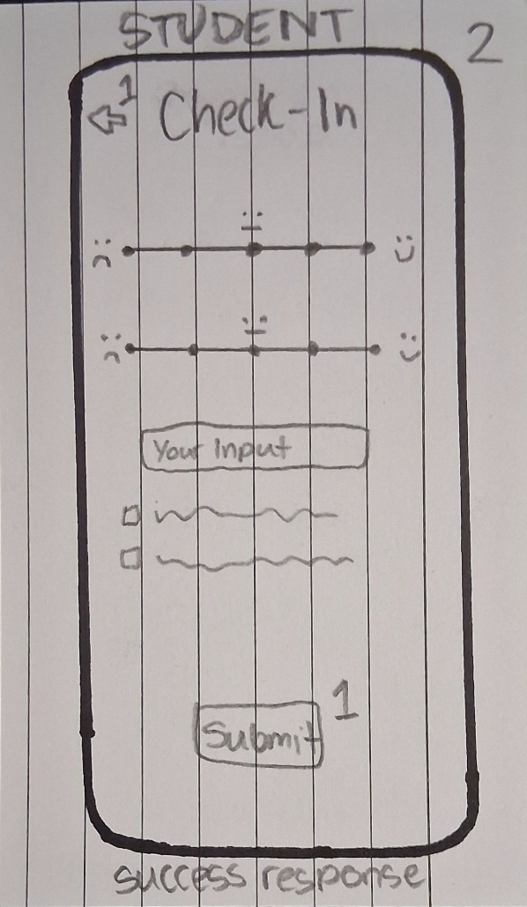

Figure 14 - Check-In Page

Step 3: Submit a Check-In (End State)

There are some initial designs of how the student will input their check-in, one example is a Likert scale in which a user can rate their current mood or agreement to a statement about their wellbeing. Another is allowing the user to input their own comments with question headers as a guide. The student could also be given the opportunity to mark if they need a meeting within the check-in. There is a back arrow in the top left to allow the user to leave the page without submitting, giving the user freedom to come back to a check-in later or if they entered the page incorrectly (Gonzalez-Holland et al., 2017).

#### High Fidelity

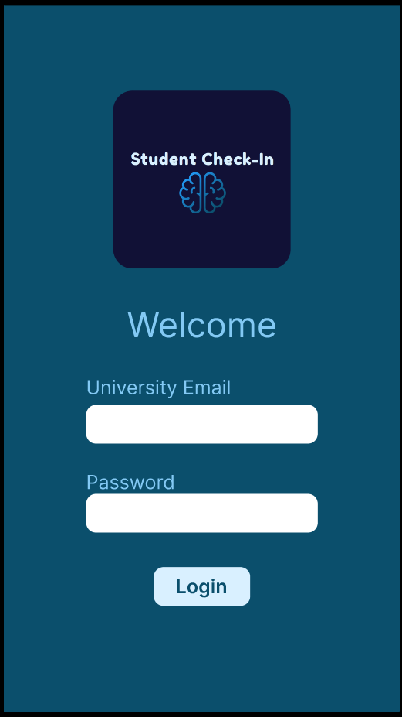

Figure 15 - Login Page for Mental Health App

Step 1: Open the App

Upon opening the app the user is greeted with the login page. Each user flow will begin with the login page, which has been kept simple. The student requires a university email and password to log in as the app is directed towards students. The app logo uses the darkest blue #111136 as contrast to the app background and has a two-toned brain as the icon. This use of imagery is in line with Nielson’s Heuristic of matching real-world imagery with design (Gonzalez-Holland et al., 2017). Once the user has entered their credentials, they will click the login button to navigate to the home page.

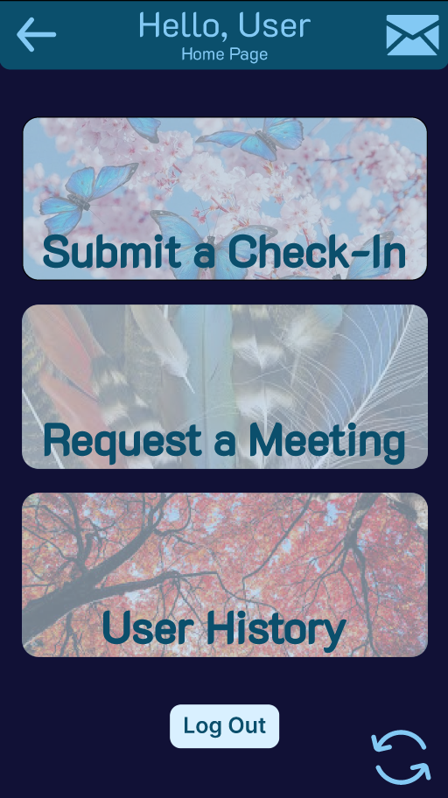

Figure 16 - Student Menu Page

Step 2: Access the ‘Submit a Check-In’ Page

The main menu page has several large buttons, each with different natural motifs. Upon hovering over the buttons, the background becomes a solid colour (#D9F0FF) for accessibility with those of lower vision, and to provide users with feedback of their actions as given in Don Norman’s Heuristics (*Don Norman’s Principles of Interaction Design | by Sachin Rekhi | Medium*, 2017). There are also buttons to log out and to check notifications. The background is the darkest shade and the header uses the login page’s background. There is also a button at the bottom right to switch between student and staff views, this is for demonstrative purposes and will not be included in the finished product. The user must click on the ‘Submit a Check-In’ to access the check-in page.

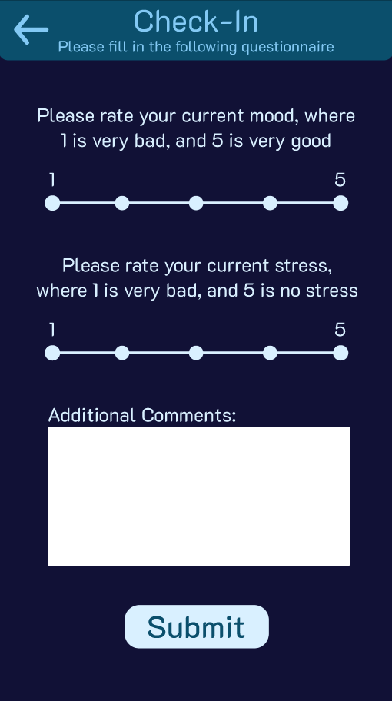

Figure 17 - Check-In page

Step 3: Submit a check-in (End State)

The Check-In page has some Likert scales which allow the user to rate their moods and stress. The student also has the opportunity to add their own comments in a text box. The scales use #D9F0FF instead of white to keep within the app’s colour scheme, but the text box is white for ease of reading. There is a simple submit button at the bottom of the page, and a back button to leave the page without submitting to allow for user freedom (Gonzalez-Holland et al., 2017).

### Student requests a meeting with their PS

#### Low Fidelity

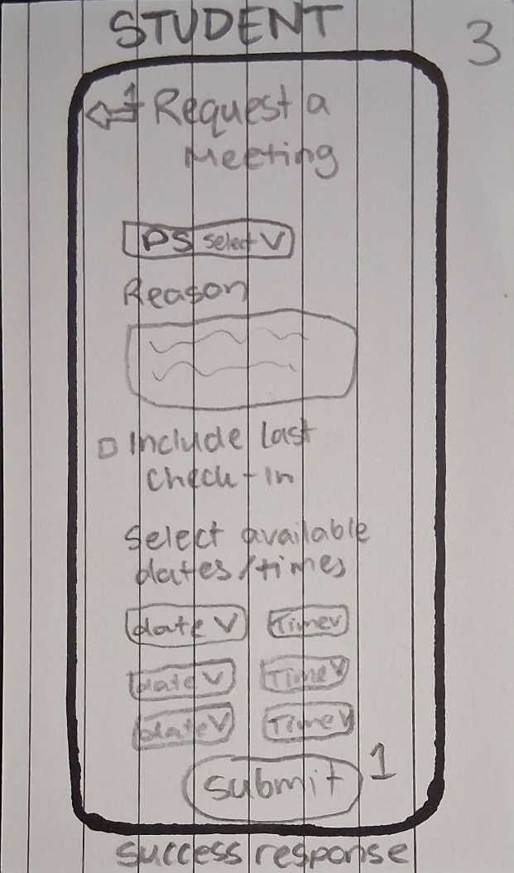

Figure 18 - Meeting Request page

Step 3: The student submits a meeting request (End State).

Above are some initial ideas of what the user may need to submit to their PS for a meeting, such as possible dates for an appointment, a reason for the appointment, and a possibility of selecting another academic advisor to be cc’d in. This would allow the student to also notify a lecturer if any issues occurred. Once again a back arrow is included as well as button labelling and a page title, giving the user clear feedback of their actions taking them to this page.

#### High Fidelity

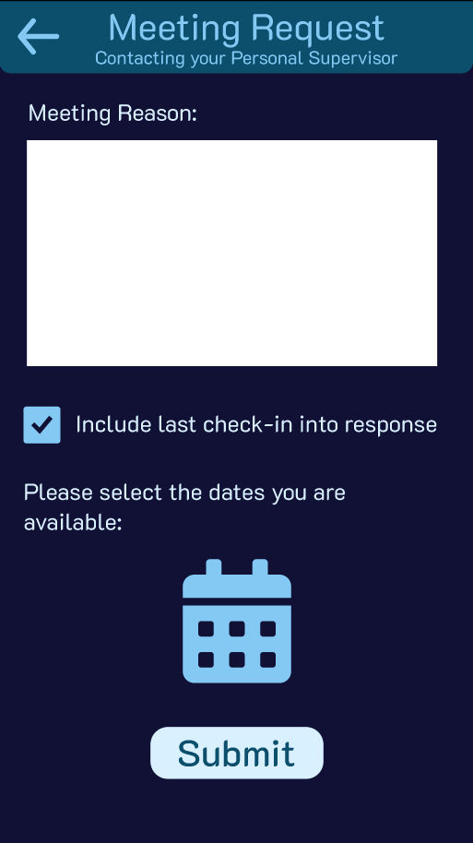

Figure 19 - Student Meeting Request page

Step 3: Submitting a meeting request (End State)

As shown in the previous user flow, the user will have logged in and clicked the “Meeting Request” button as shown on the student menu page (fig 11). The user is greeted with a text box allowing the student to give context for their meeting request and to alert the personal supervisor of any additional considerations which weren’t covered in the check-ins. The student also has the option to include their last check-in with the meeting request to provide additional information. The page has a calendar button which with implementation would allow the student to choose up to 3 dates on which they are free for a meeting. After this design I would now also include a way to specify if the user wanted an online or in-person meeting. The text on the page uses the lightest colour #111136, however the text box remains white for visibility. Once the user has filled in the specified fields, the user can submit the request using the large button at the bottom. The student can still leave the page without submitting via the back button in the top left. This main bar will be the same across each page in accordance with the Consistency principle (*Don Norman’s Principles of Interaction Design | by Sachin Rekhi | Medium*, 2017).

### PS reviews a report from a Student

#### Low Fidelity

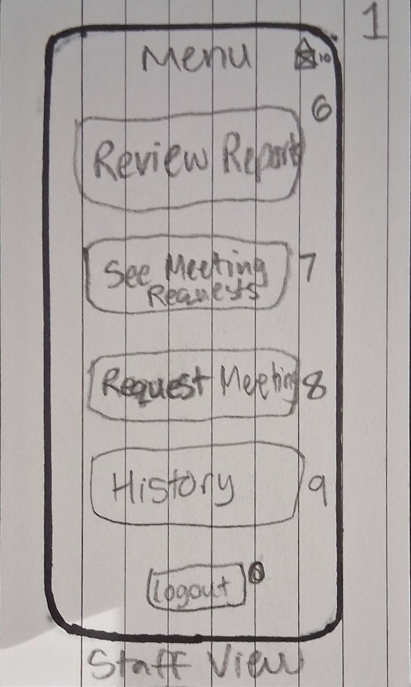

Figure 20 - Staff Menu page

Step 2: Accessing the report review page

This is the PS version of the main menu, giving staff additional features to help students and organise their schedules. The staff have the ability to request meeting with students as well as accept requests from students, as a PS may decide a conversation is needed after a check-in submission or for any academic intervention. The PS has the option to log out at any time giving them the freedom to leave the page without leaving the application.

Once the staff member has selected the “Review Report” tile, they are directed to the report review page.

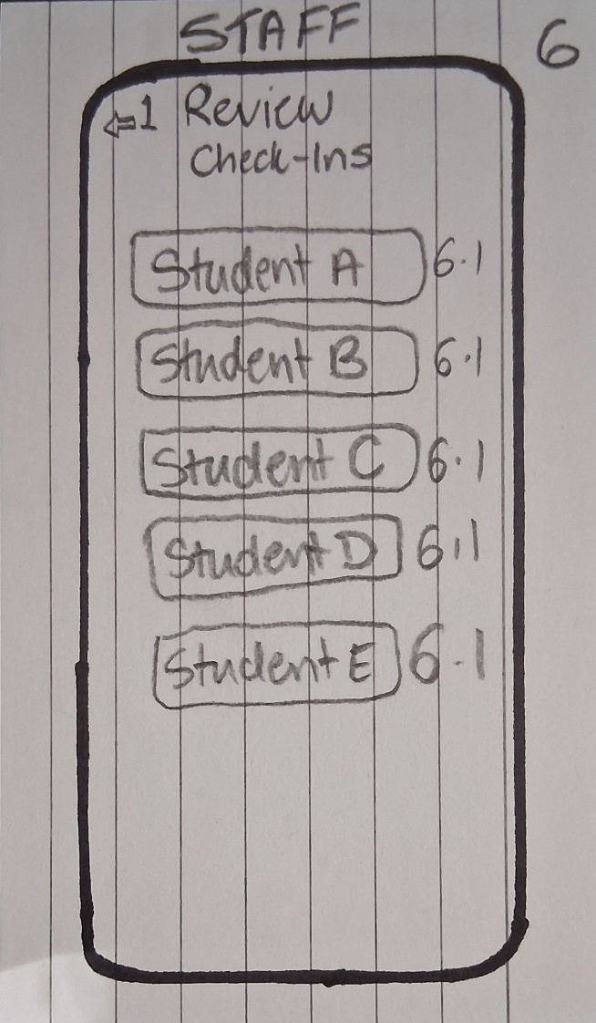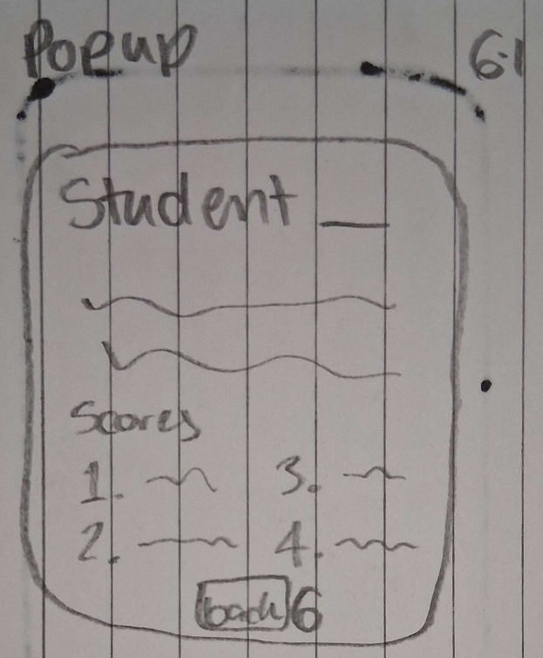

Figure 21 - Student Check-In Review page

Figure 22 - Popup for Student Check-In Review page

Step 3: Reviewing a student check-in (End State)

The PS is shown a list of unreviewed student check-ins which have been submitted. Once the PS selects a student check in a popup is shown with the basic information of the check-in. The user can expand this popup to show the whole review if need be, giving the user flexibility in how they review the check-in (Gonzalez-Holland et al., 2017). The popup also has a back option that takes the PS to the original Report Review page.

#### High Fidelity

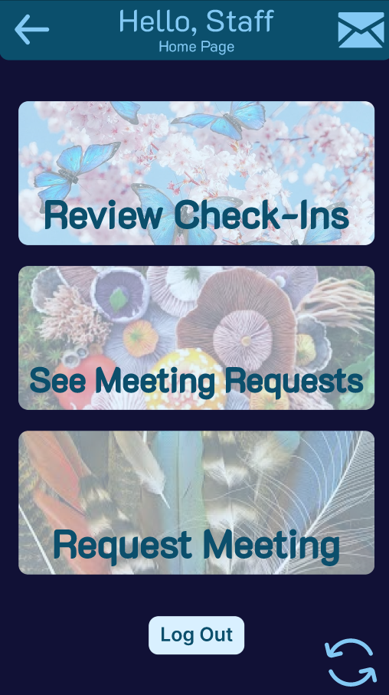

Figure 23 - Staff Menu Page

Step 3: Accessing the Staff Menu

Once the staff member has logged in with their credentials, the PS would be immediately taken to this menu as it has special features reserved for staff. Though in the final version this menu will appear first, for ease of demonstration the user first must access the staff menu via the change button at the bottom right of the page. As with the student menu the user has three main features, all of which change upon hovering for ease of reading.

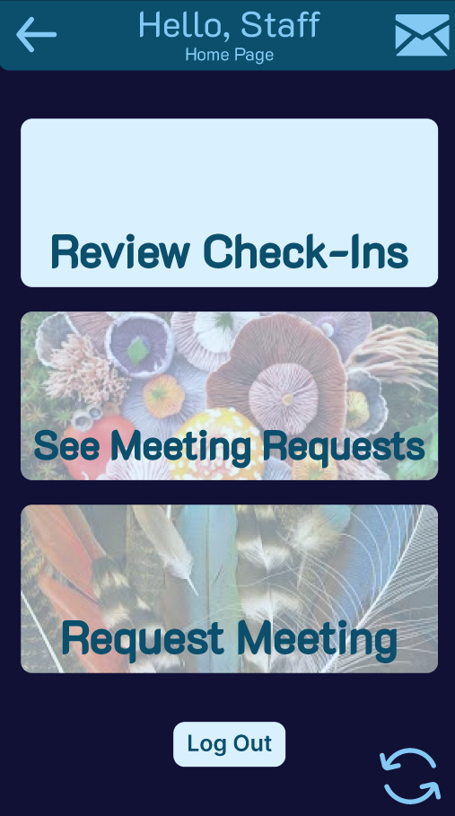 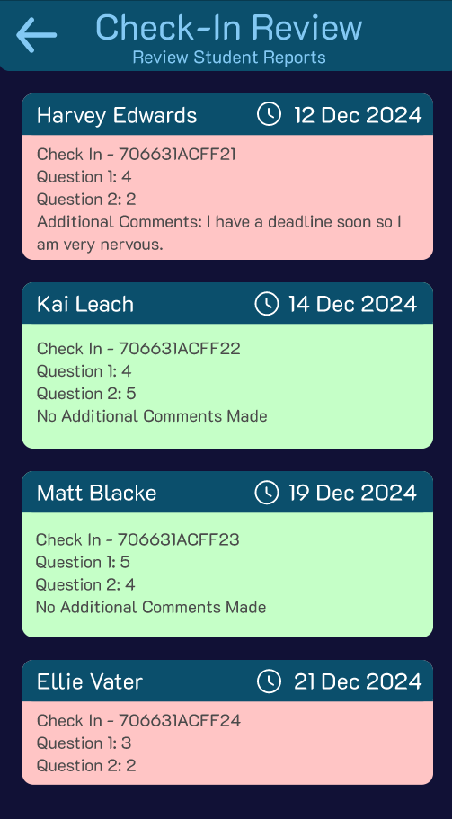

Figure 24 - Staff Menu page, on Hover

Figure 25 - Check In Review page

Step 4: Accessing the Check-In Review page (End State)

Upon clicking the Review Check-Ins button, the user is taken to the Check-In Review page. The page displays all of the most recent student check-ins and changes colour depending on how the student has responded to the check-in, with green for those who have responded positively, and a light red for those who have raised concerns. This allows the personal supervisor to check on the overall condition of their student body at a glance. The use of green and red in this instance is another version of mapping, as most people associate green with good and red with warnings. (*Don Norman’s Principles of Interaction Design | by Sachin Rekhi | Medium*, 2017). Each check-in has the recorded date, name, and student ID of each student so the PS can easily check up on them.

### PS responds to a meeting request with their Student

#### Low Fidelity

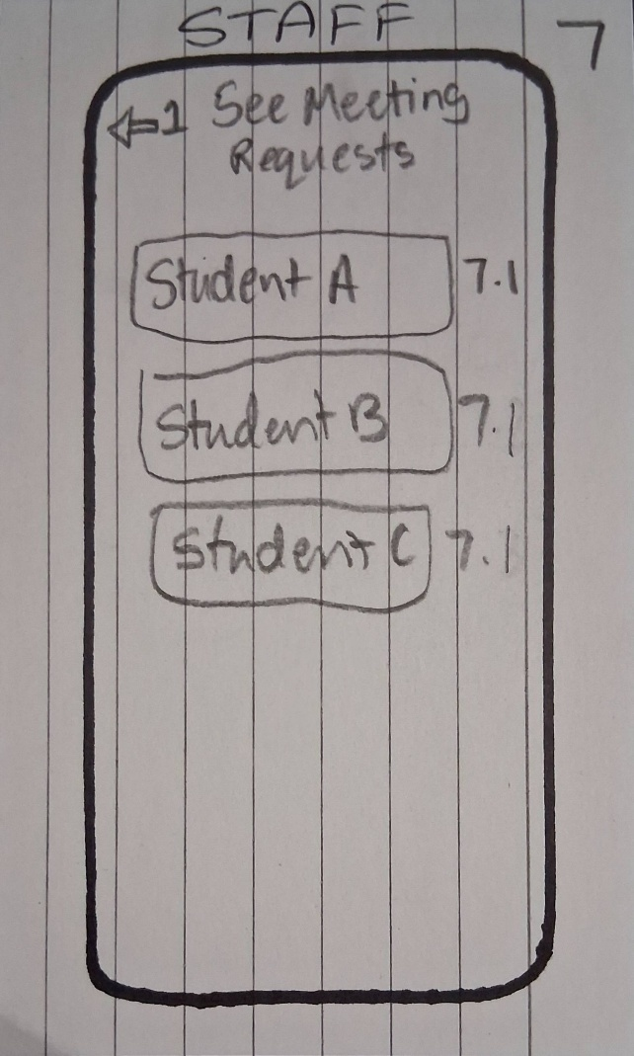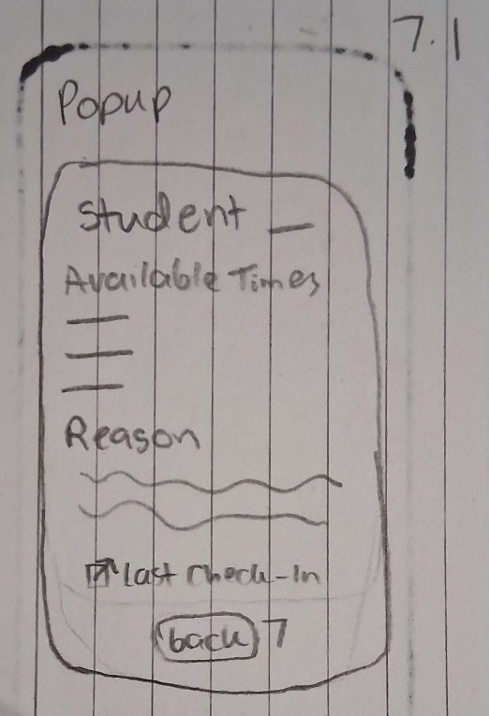

Figure 26 - Meeting Request Review page

Figure 27 - Popup for Meeting Request Review page

Step 3: The PS reviews a student meeting request (End State)

The user is greeted with another list of student meeting requests, which they can review and select a date/time which is free for them. Once again the user can expand the popup with the given information or leave the page. The PS can also send a response if they cannot make the student’s specified dates/times or request that the meeting be in-person or on teams.

#### High Fidelity

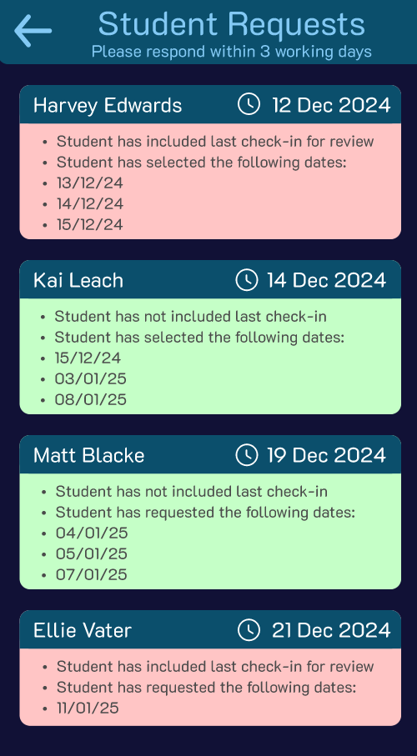

Figure 28 - Student Meeting Request page

Step 4: Access the Meeting Request page (End State)

From the staff menu the PS can select the “See Meeting Requests” page and be sent to an overview of each student’s request. Once again the requests are colour coded depending on whether the student has included their last check-in. Each student sends up to three available dates, which the PS can choose from depending on their schedule. If the PS has not availability on those days they will contact the student directly via Teams to find a time.

## Case Study 2 – Home Automation app

### User Goals

Users:

* Homeowner

User Goals:

* The Homeowner can toggle their lights, heating, and A/C using the app
* The Homeowner can track their usage of each feature
* The Homeowner should be able to set routines for their peripherals, prompted by the app.
* The Homeowner can add to or change their BAS connections.

Expansion:

As the user goes through their week, the app could monitor usage of lights/heating and at what times to create a pattern or “Routine” for the user, which over time could reduce emissions and create better behaviours for the homeowner regarding their light pollution and energy efficiency. Reducing the energy output can also create a positive environmental impact as the user can turn off unnecessary lights/stop heating certain unused rooms, preventing waste.

### Figma Link:

<https://www.figma.com/design/9EYR5ztbMSF0zf3MP29z0J/UIUX---BAS?node-id=0-1&t=CVQDNIwcFgDJMuwI-1>

### General

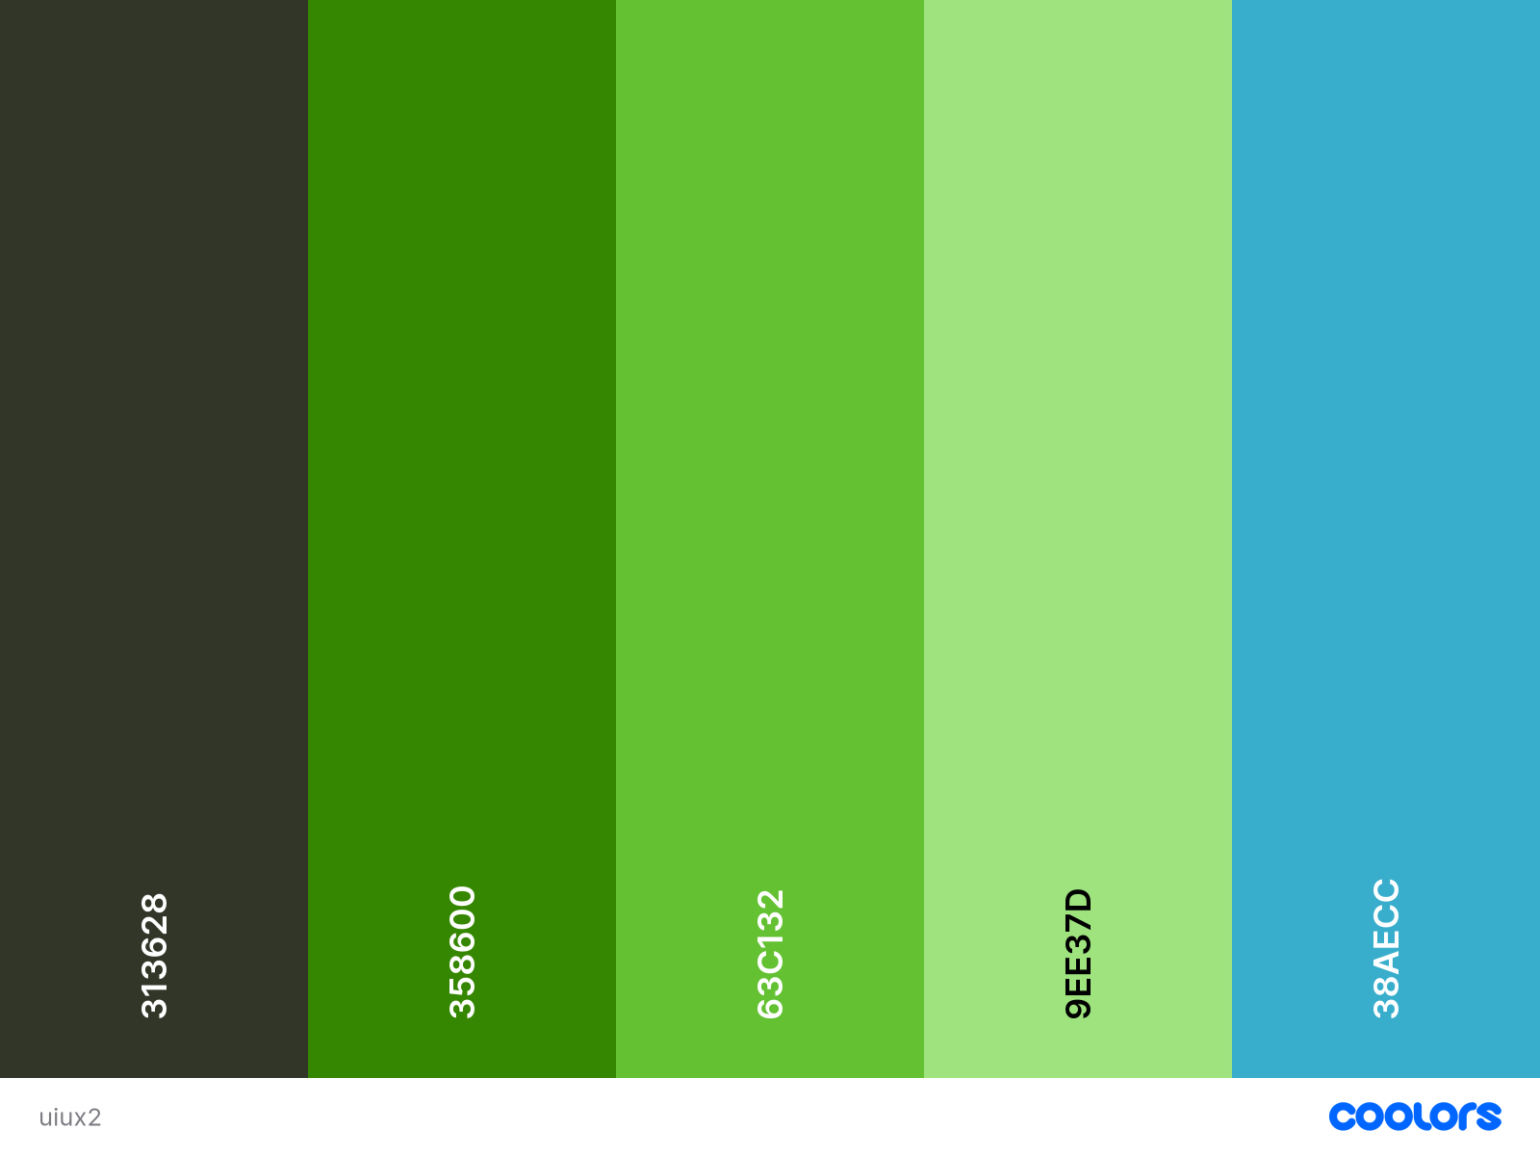

Figure 29 - Colour palette for the BAS webapp

The colours chosen are designed to reflect a natural tone, using an earthy brown (#313628) as the darkest colour, yellow-toned greens for the main colours (#358600, #63C132, #9EE37D), and a green blue for the contrast colour (#38AECC). Green is associated with nature and growth, which would suit the eco-friendly theme of the app. Green also has a technological association, evoking imagery of computer components like early 2000s motherboards and even the Matrix. (Green Color Psychology, Symbolism and Meaning, 2015).

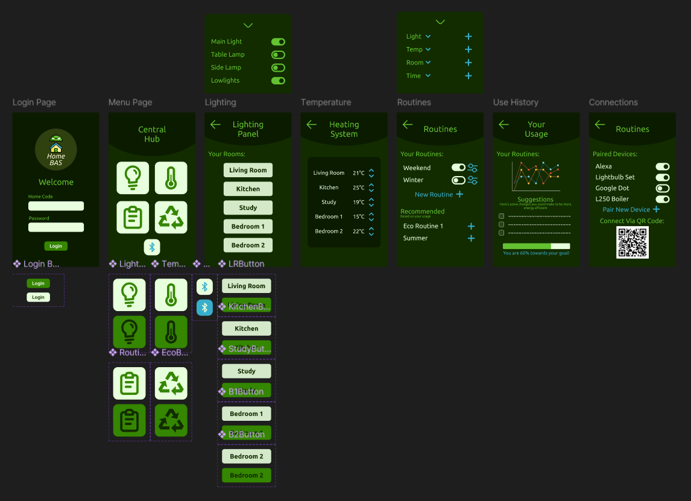

Figure 30 - Full view of each Figma page in the High-Level Prototype

### The Homeowner toggles lighting/heating

#### Low Fidelity

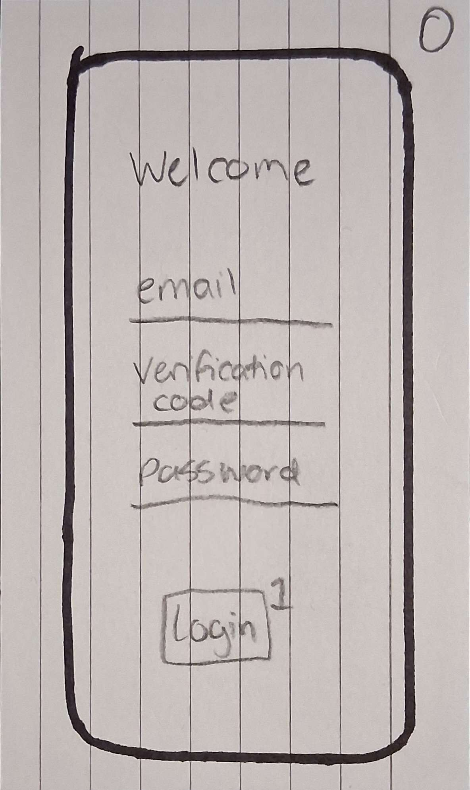

Figure 31 - Log In page

Step 1: Log Into the app

The user is asked to input several fields such as an email, password, and a verification code which improves the security of the app. The log in is uncluttered and has a clear process throughline, in keeping with error prevention (Gonzalez-Holland et al., 2017).

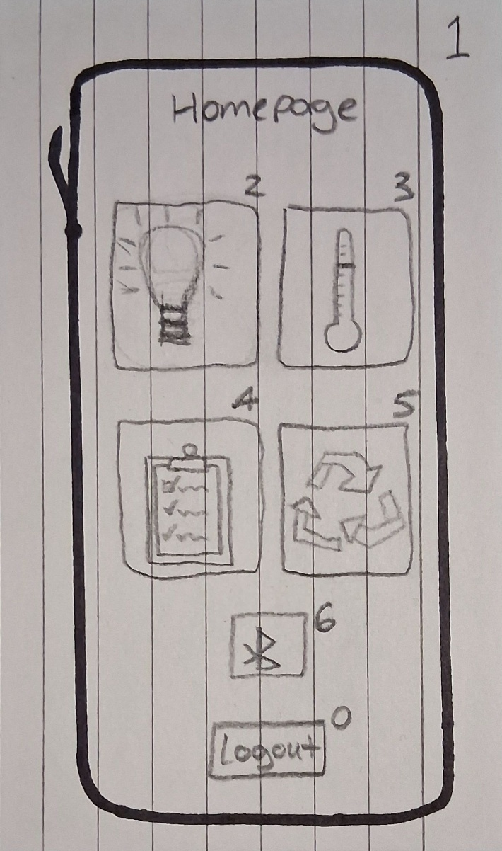

Figure 32 - Menu page

Step 2: Access the Lighting/Temperature settings

The menu page offers large tile buttons for each page, as well as a smaller tile for connecting peripherals to the BAS. The tiles use well-known symbols to signify each tab, allowing the user innate knowledge of the features without needing labels.

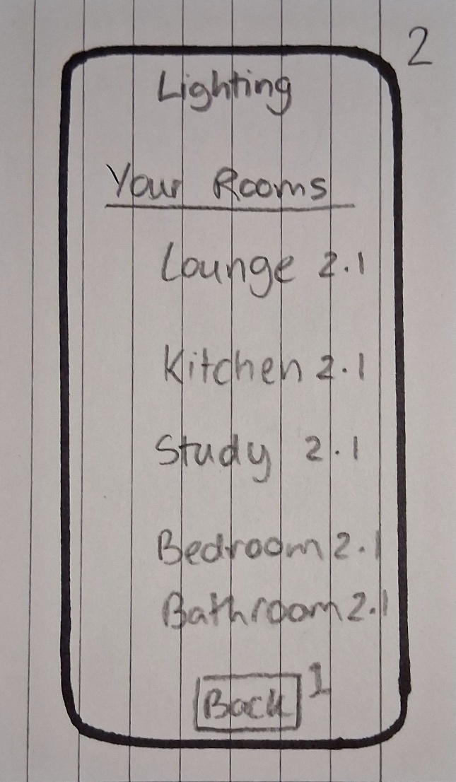 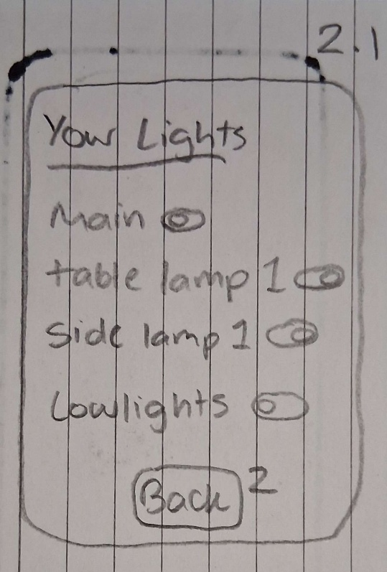

Figure 33 - Lighting Settings page

Figure 34 - Lighting Settings page Popup

Step 3.1: Alter the lighting settings (End State)

The user will have a selection of rooms which they added via the connections tab. Each room will link to a popup in which the lights of that room are stored and can be toggled on/off. The separation of rooms into separate tabs keeps the page from being too cluttered and makes the user aware of which lights relate to which room. The lights can be given nicknames the user sets to make identification easier.

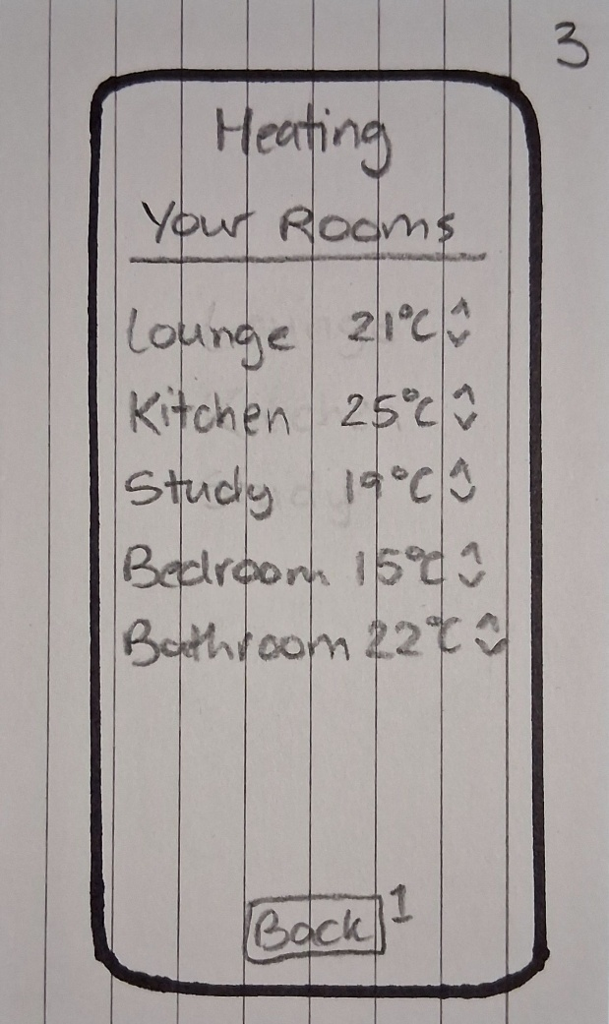

Figure 35 - Heating Settings page

Step 3.2: Alter the temperature settings (End State)

The user is presented with a list of rooms in which the heating can be modulated. Beside each room is a reading of the current temperature as well as up & down arrows to increase/decrease the temperature. Each page contains a back button which returns to the main menu (*Don Norman’s Principles of Interaction Design | by Sachin Rekhi | Medium*, 2017).

#### High Fidelity

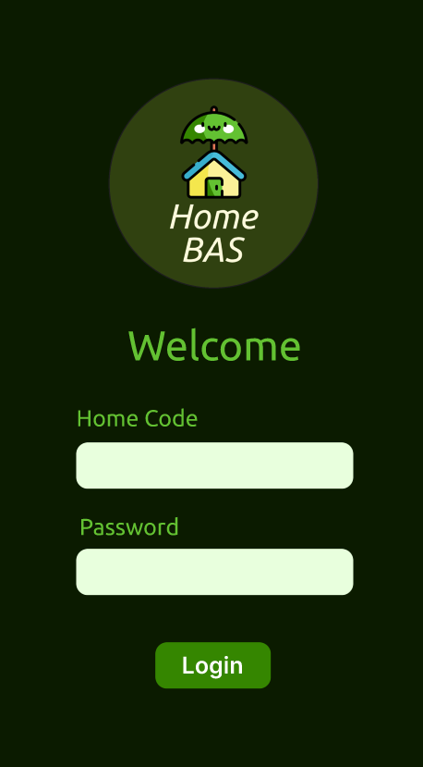

Figure 36 – Log In Page

Step 1: Log Into the app

When the user opens the app they are shown input fields for their selected home code and password, determined by the user. The background is dark (#0B1B00) which draws attention to the light (#E8FFDD) text boxes, and the clear and concise instruction for logging in to guide the user.

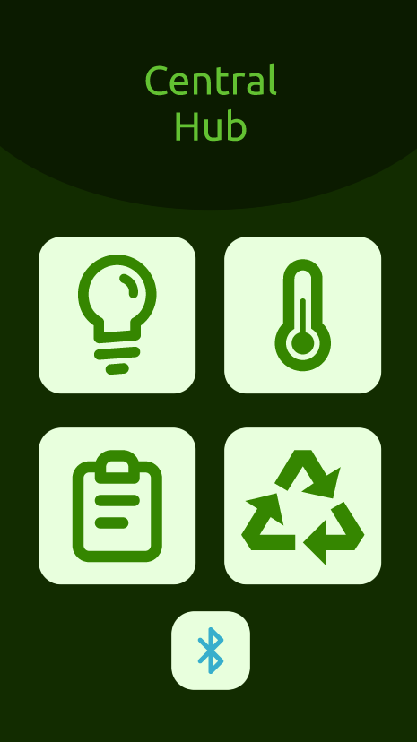 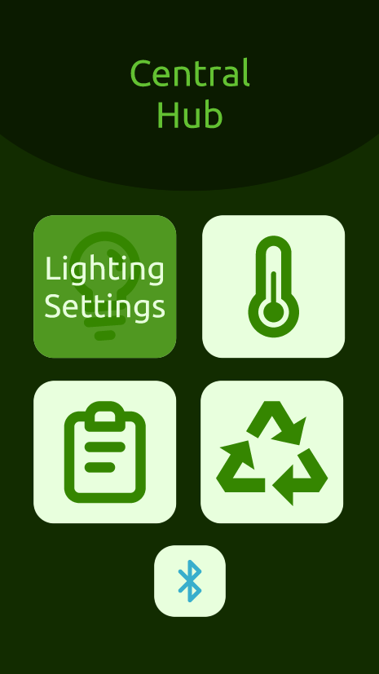

Figure 37 – Menu Page

Figure 38 – Menu Page – Highlighted button

Step 2: Access the Lighting page

The menu has four main tile icons, for each main feature of the app, as well as a smaller connections menu for the BAS devices. The tabs use a mid-green (#358600) for the icons and a very light green (#E8FFDD), but when hovered over they respond by becoming darker and show text related to their function. This is to ensure users are always aware of their actions and have signposting for each function (Gonzalez-Holland et al., 2017). The only button not to have a title is the Bluetooth button as the symbol is widely recognised as a method of wireless connection. This feature assumes the user has innate knowledge of this feature and maps the icon with the function (*Don Norman’s Principles of Interaction Design | by Sachin Rekhi | Medium*, 2017).

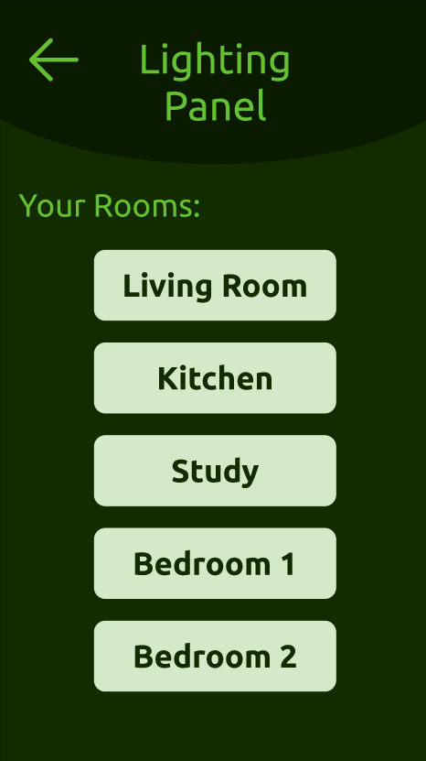 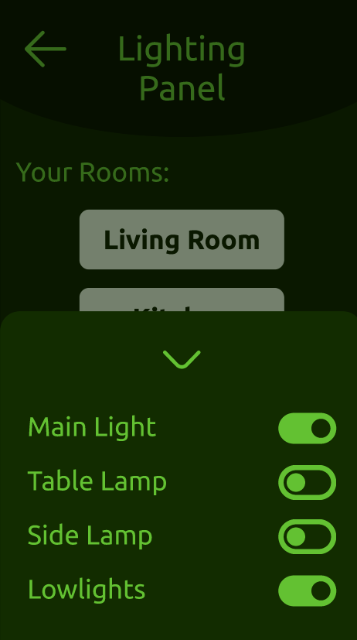

Figure 39 – Lighting Settings page

Figure 40 – Lighting page Popup menu

Step 3.1: Access the lighting toggles (End State)

The user is shown many rooms which they have added to their system. Each room has set lights which can be toggled from a popup menu when clicked. The user can add lights and rooms via the connections tab on the main menu. The title bar decreases in size between the menu page and the function menus but keeps the colour and title font/colour to keep the app design consistent, (*Don Norman’s Principles of Interaction Design | by Sachin Rekhi | Medium*, 2017). The user can leave the popup by either clicking outside the popup or clicking the close arrow at the top of the popup, providing multiple ways to exit (Gonzalez-Holland et al., 2017).

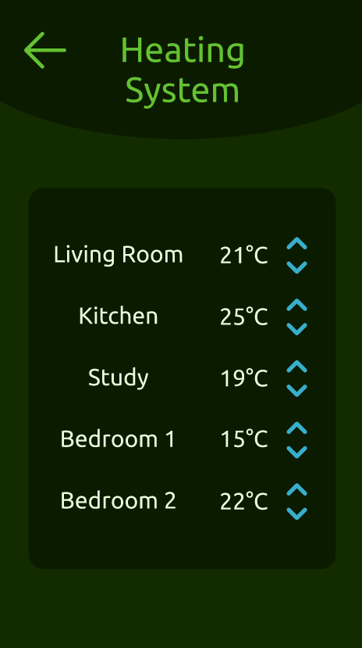

Figure 41 – Heating Settings page

Step 3.2: Access the heating toggles (End State)

The heating system is much like the lighting as there are settings for each room, which the user can change using the highlighted arrows. As the BAS is connected to the heating, changing the value on the app would update the boiler and therefore either add or remove heating from the radiators/underfloor heating. The arrows use the accent colour (#38AECC) as contrast to the green app to highlight where the user can interact with the system, showing the constraints of the app (*Don Norman’s Principles of Interaction Design | by Sachin Rekhi | Medium*, 2017).

### The Homeowner can see their overall usage over a given period

#### Low Fidelity

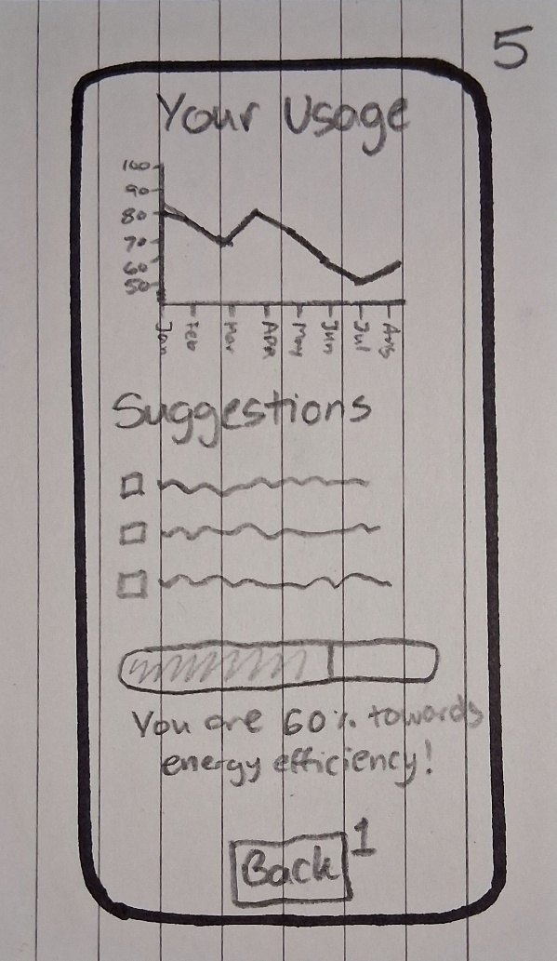

Figure 42 - User History page

Step 3: Access the user’s usage history (End State)

The usage page will display the user’s lighting/temperature readings between a specified date (1 month, 6 months, 1 year, etc.) as well as generated suggestions for the user to improve the use of lighting/heating in their home. A user goal is set in which a user can specify the energy limit they wish to get below, the progress of which is displayed at the bottom.

#### High Fidelity

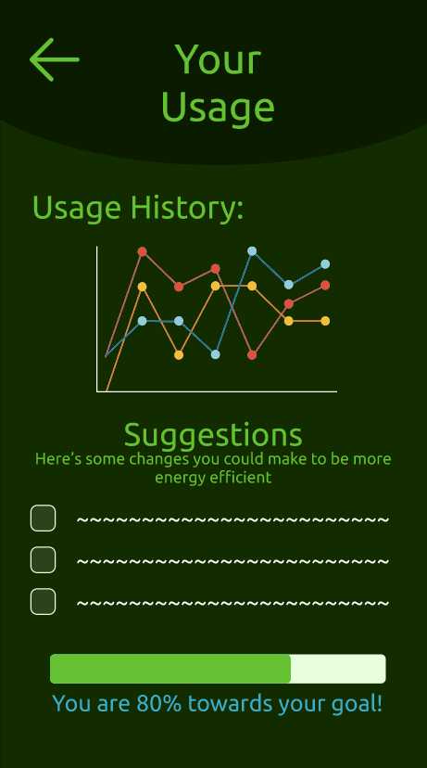

Figure 43 – User History page

Step 3: Access the User History page (End State)

The homeowner is shown their monthly usage as well as given suggestions for making their home system more energy efficient. The user has a preset goal of efficiency which encourages them to use less electricity which in turn makes the system more environmentally friendly. Allowing the user to review their habits can help them create routines which also prevent the user from forgetting to turn off lights/heating.

### The Homeowner can use a recommended routine or set one of their own

#### Low Fidelity

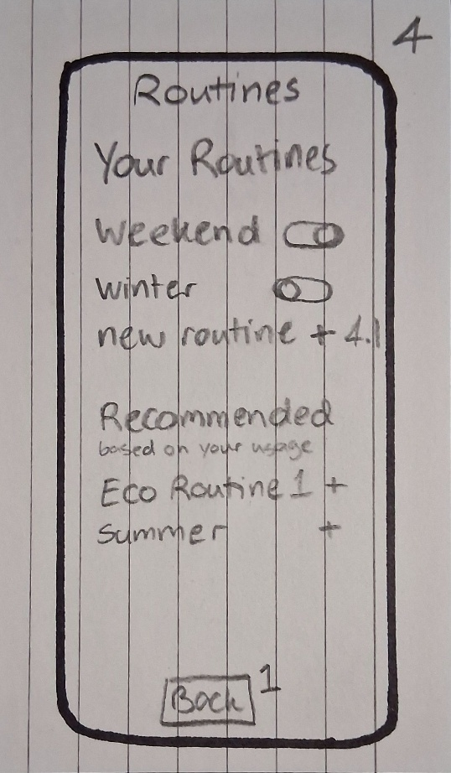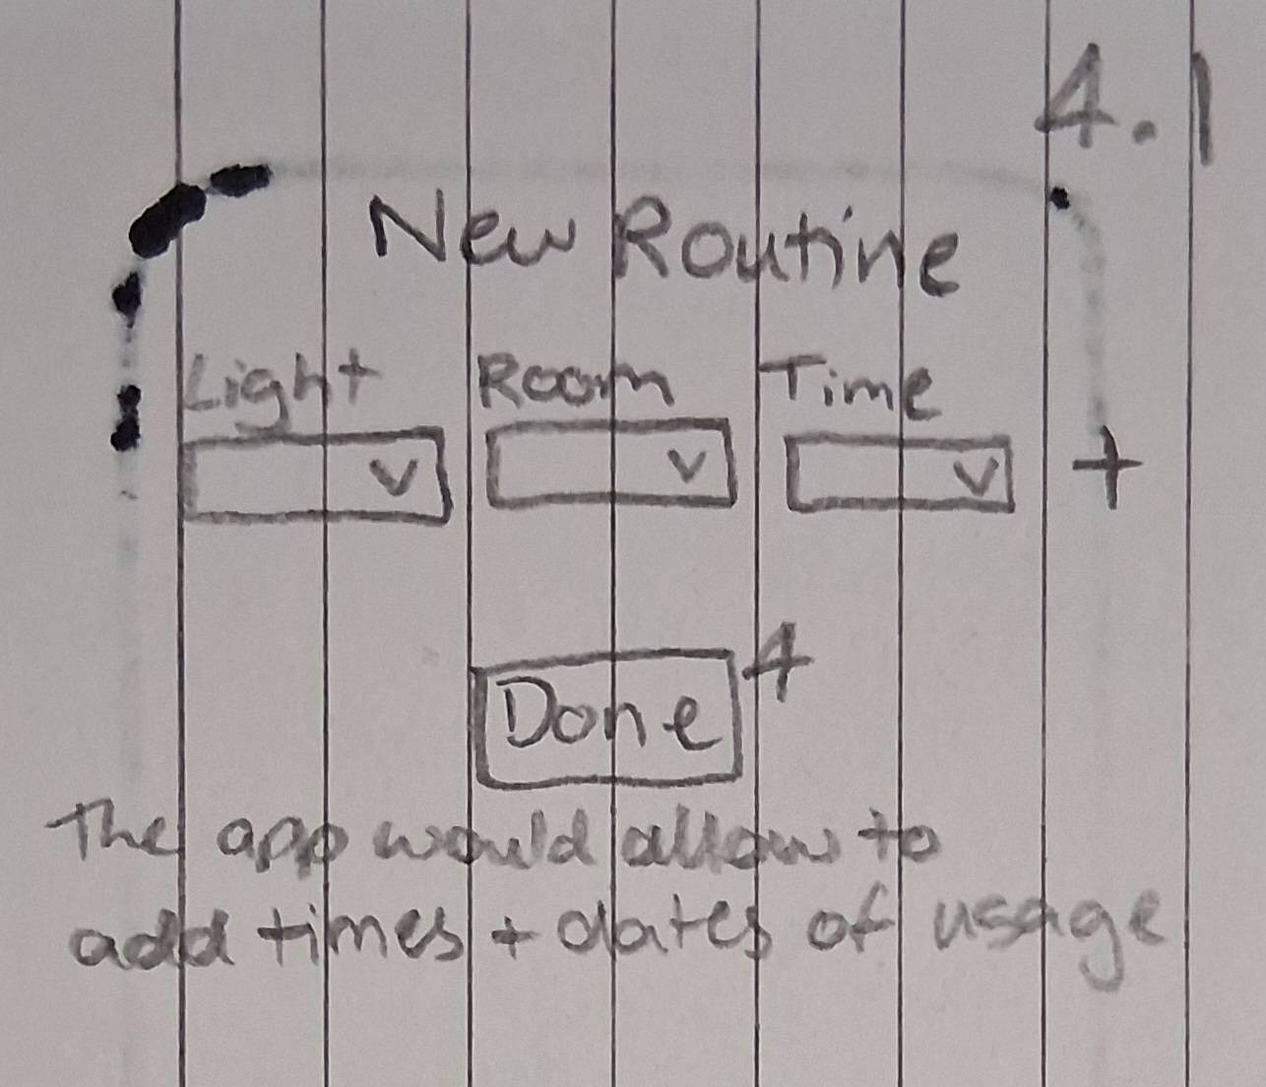

Figure 44 - Routines page

Figure 45 - Routines page Popup

Step 3: Access the Routines settings (End State)

The existing routines are stored at the top of the page, with toggles to activate them as the user wishes. If the user adds a new routine then a popup menu is shown which allows the user to add which lights in which rooms become activated at what times. Once the user hits done they are taken back to the main page and can then toggle their new routine. The app will suggest routines based on the homeowner’s usage and patterns recorded.

#### High Fidelity

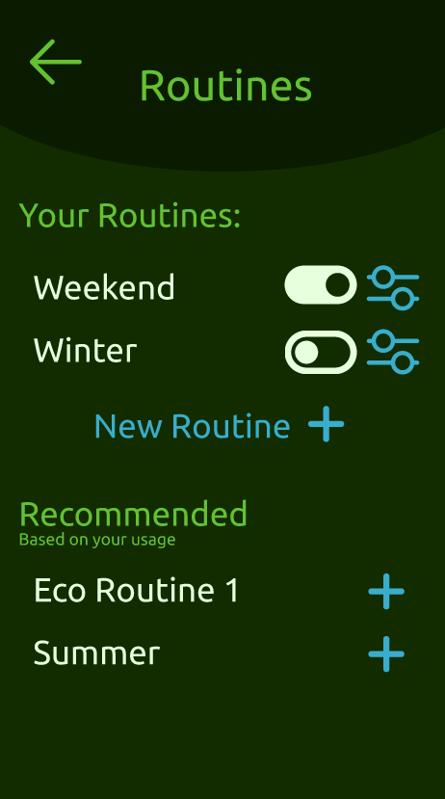 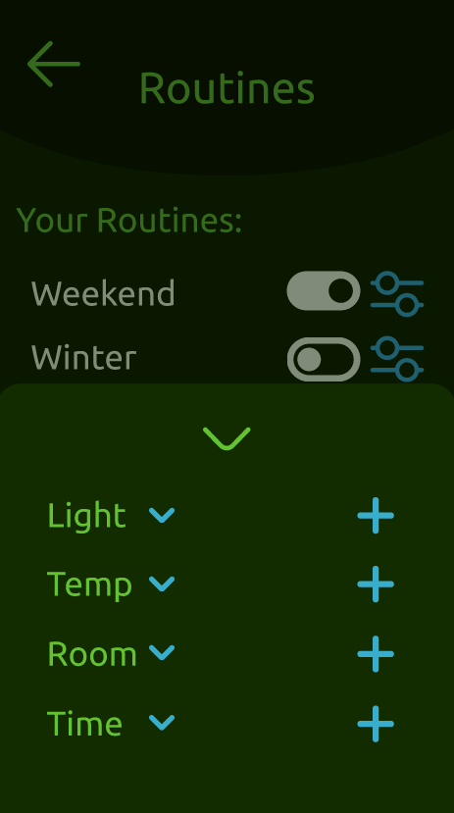

Figure 46 - Routines page

Figure 47 - Routines page, popup

Step 3: Access the Routines page

The Routines page has several controls, the user can turn on and off their routines, edit them, or create a new routine. Upon clicking the new routine option a popup opens which allows the user to add selected lights, rooms, temperatures, and times to allow full customisation of their BAS. There are also some pre-made or recommended routines that the app has calculated based on the homeowner’s changes. The settings and addition icons are in blue to signify they are user-controlled; however the toggles are the same colour as the text for congruity (*Don Norman’s Principles of Interaction Design | by Sachin Rekhi | Medium*, 2017).

### The Homeowner can add to or change their BAS connections.

#### Low Fidelity

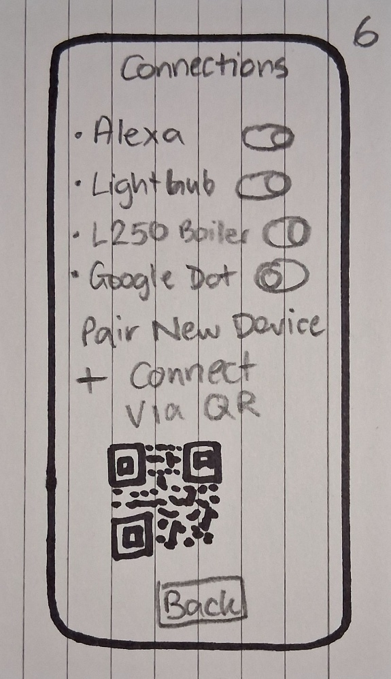

Figure 48 - Connections page

Step 3: Access the Connections page (End State)

To connect the BAS peripherals, the user must first pair them to the app. The user can toggle existing paired devices, and pair new devices using the plus icon. The user can also pair a peripheral using a generated QR code based on the user’s home code for devices with scanning capability.

#### High Fidelity

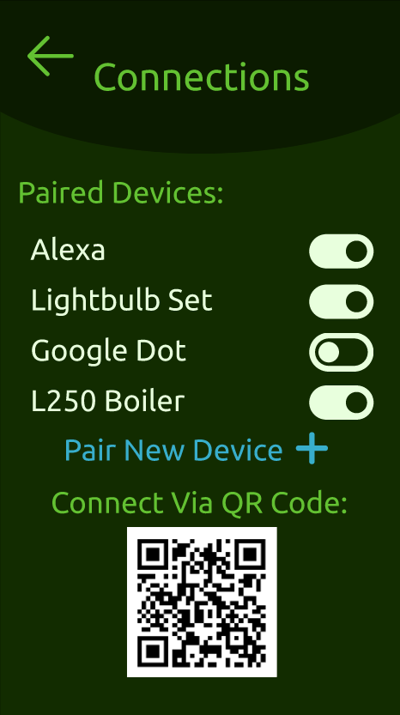

Figure 49 - Connections page

Step 3: Access the Connections page (End State)

The paired devices are shown in the top as a toggle list, allowing the user to quickly turn off/on connections as needed. The user can also connect a new device via QR code if the peripheral has a scanner, or pair a new device via Bluetooth/LAN. Once again the setting is highlighted in the blue contrast colour, keeping with the standard set across the app (*Don Norman’s Principles of Interaction Design | by Sachin Rekhi | Medium*, 2017).

# Part 3 – User Flows of Front-End Mock-Ups

## 3.1 – Implemented User Goals

### User Goals

* The User must be able to change the heating/lighting of a given room
* The User must be able to add/enable a routine
* The User must be able to track their usage and see suggestions on optimisation
* The User must be able to activate a peripheral

### General

The app was designed to be used in mobile mode, as such the ideal resolution used during the implementation was 667*375.

### The User must be able to change the heating/lighting of a given room

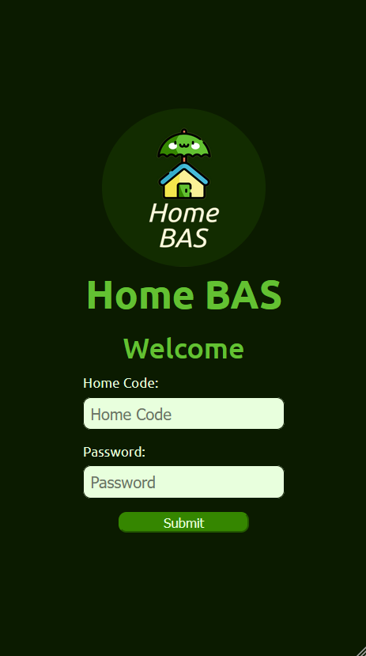

Figure 50 - Log In page

Step 1: log into the app

The log in page stayed relatively the same, with slight changes in style on items such as the submit button and text boxes.

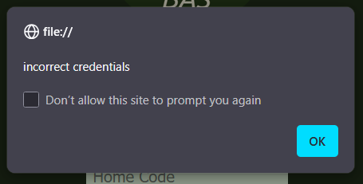

Figure 51 - Incorrect credentials error message

If the user provides no credential or the credential given are incorrect, an error dialogue is shown.

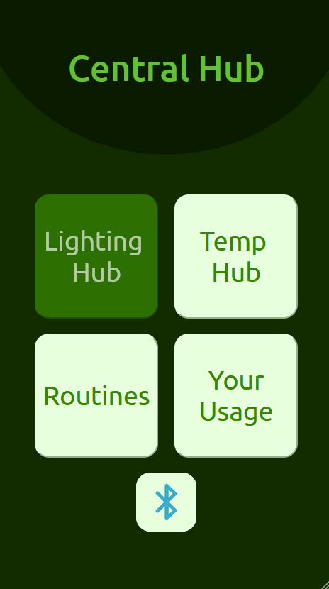

Figure 52 - Central Menu page

Step 2: Access the Lighting Hub

Unlike the prototype, the main tiles do not use icons and instead have clear text to label each button. The background and connections button remain the same.

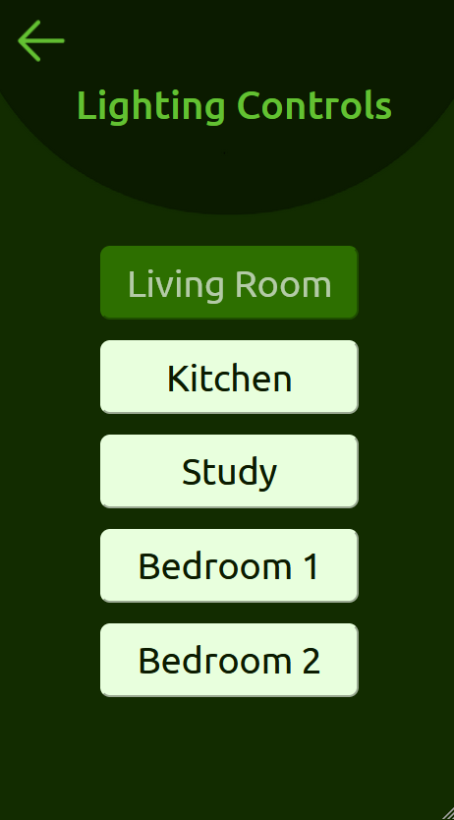

Figure 53 - Lighting Control page

Step 3.1: Alter a lighting setting (End State)

The page is identical to the prototype with the exception of the removal of the “Your Routines:” heading, as the label is redundant.

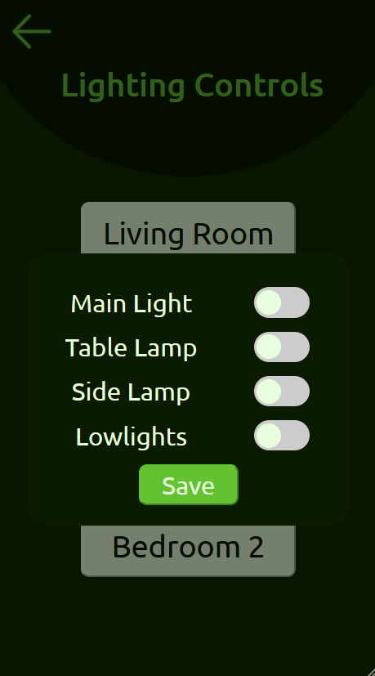

Figure 54 - Lighting Control page Popup

The popup is changed from appearing from the bottom to being overlayed at the centre of the page. The save button closes the popup, or alternatively the user can click outside the box to close it without saving.

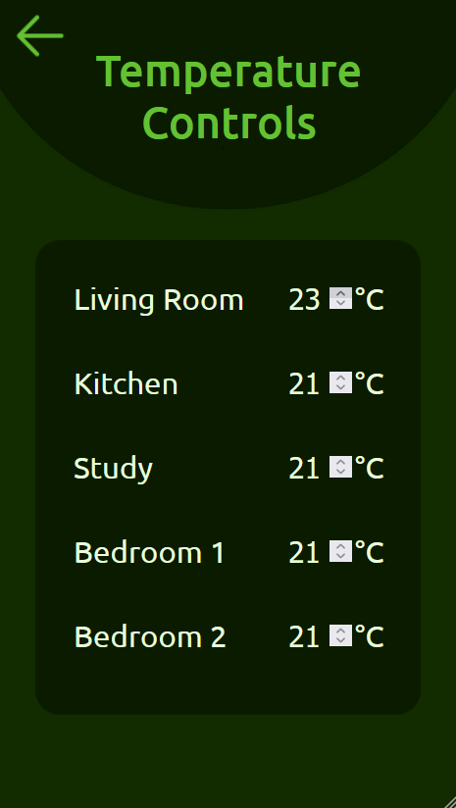

Figure 55 - Temperature Controls page

Step 3.2: Alter the temperature of a given room (End State)

The prototype and final versions of this page are the same, with arrow keys to alter the values given.

### The User must be able to add/enable a routine

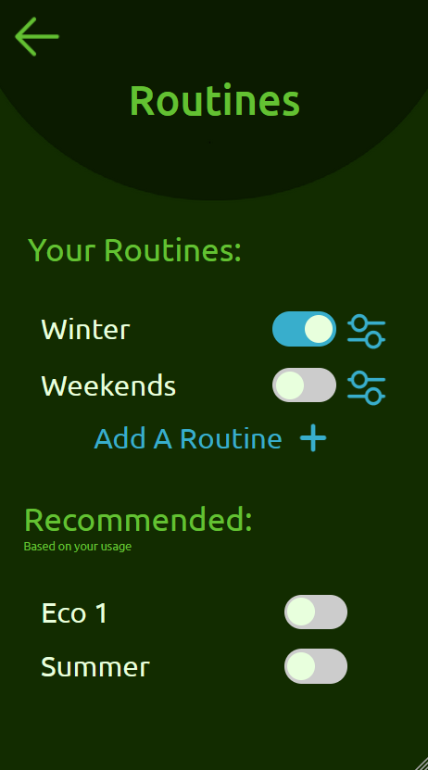

Figure 56 - Routines page

Step 3: Add a routine (End State)

These pages were largely the same but have the same change in overlay as the lighting page.

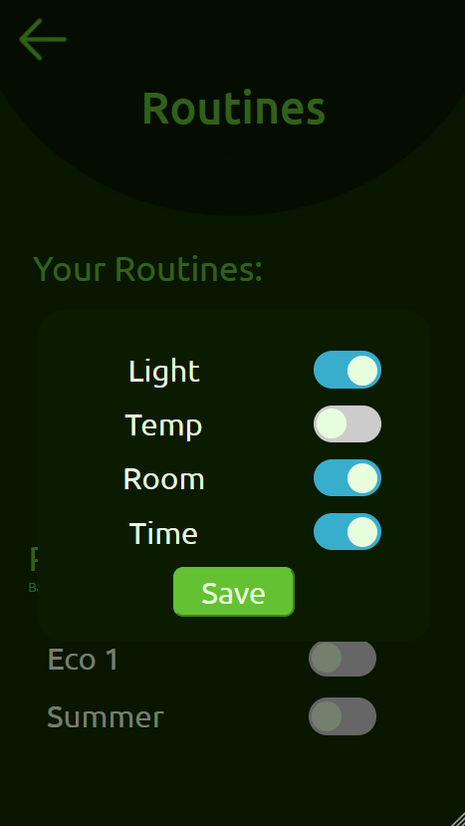

Figure 57 - Routines page Popup

### The User must be able to track their usage and see suggestions on optimisation

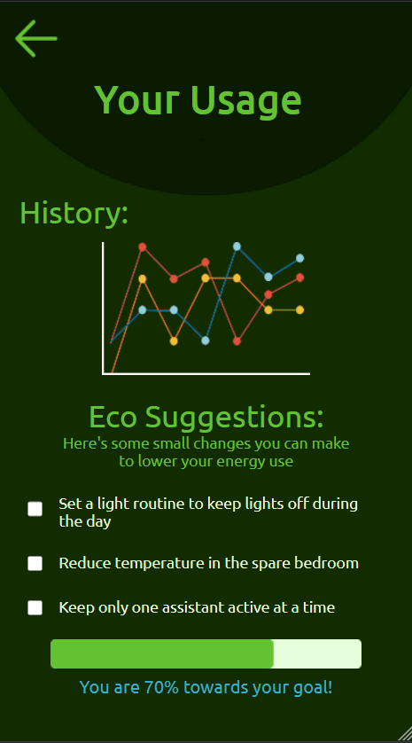

Figure 58 - User History page

Step 3: Access user history (End State)

This page implements tick boxes to allow the user to signify a goal has been achieved or a suggestion has been seen. Given a back end this would change the progress to be more filled.

### The User must be able to activate a peripheral

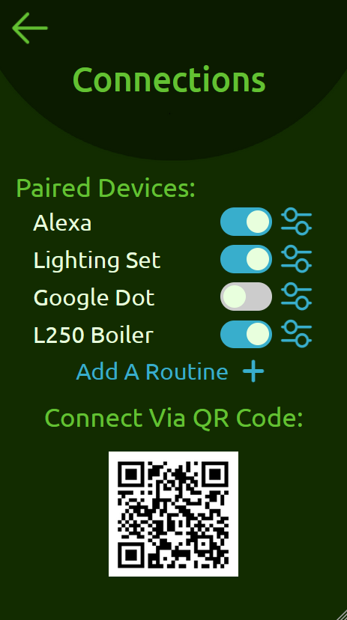

Figure 59 - Connections page

Step 3: Toggle a peripheral (End State)

As shown the toggles can be activated/deactivated, which would lead to API functionality with a device.

## 3.2 – Code Overview

### GitHub Link:

<https://github.com/Kallister-exe/UIUX.git>

### Coding Features

#### Toggle Switches

My most prevalent attribute was the toggles which allow users to activate/deactivate various features or options within the app. 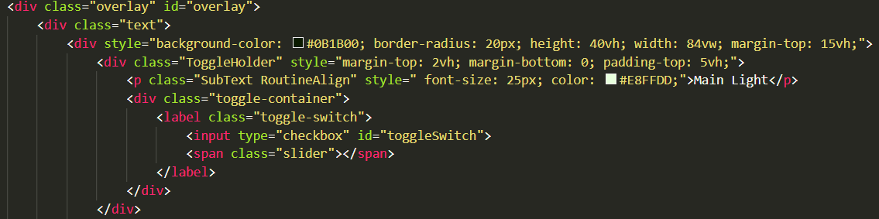

Figure 60 - HTML code of Lighting toggle

The above code is one of the toggles used on the lighting page for the “Main Light”. Dividers we used to keep the toggle in line with the label text and in some instances a settings button.

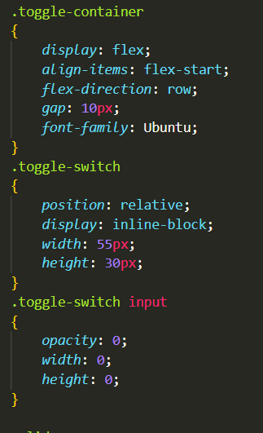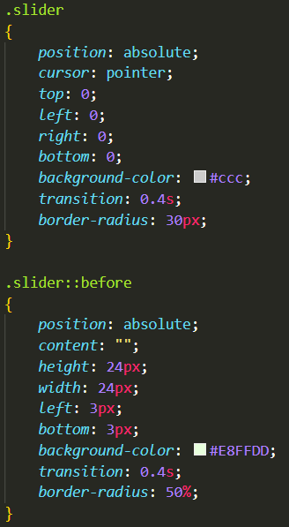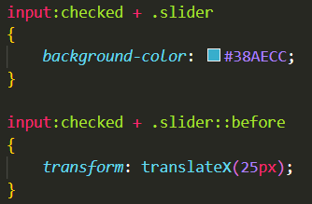

Figure 61 - CSS code of Toggle Animation

The .toggle-container and the .toggle-switch sets the dimensions of the switch, the .input:checked + slider methods allow the change from off to on. The .toggle-switch input hides the original design of the toggle which is an edited tick box. There was no JavaScript necessary for these changes as the original tick box type already had on/off functionality, and all visual changes were handled by the CSS.

#### Overlays

Another major feature was the overlays of the Lighting and Routines pages.

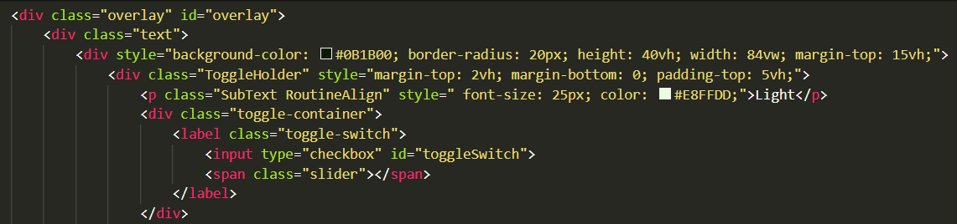  


Figure 62 - HTML for Routines Overlay

The HTML above shows the dark green container box for the routine settings, as well as the div container for the overlay itself. At the bottom of the container box is a button with the JavaScript command “off()” which deactivates the overlay. Above the overlay code are buttons which activate the overlay using the “on()” method.

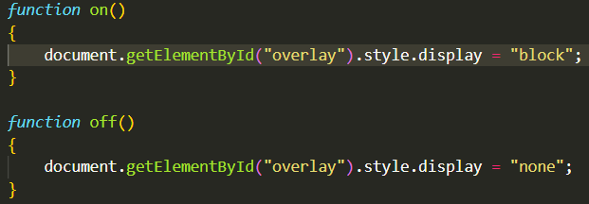

Figure 63 - JavaScript for the Overlay methods

The JavaScript activates a change within the CSS to either make the overlay visible or transparent. This JS is called from another file as the methods are used by multiple pages.

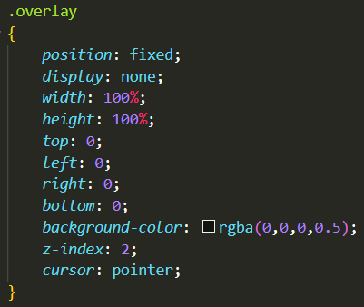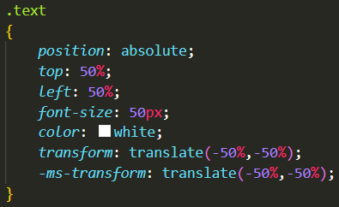

Figure 64 - CSS for Overlay methods

The overlay method once activated will create a dim on the background to focus the user’s attention on the overlay itself. A generic text style sheet is added for the overlay to reduce repetition.

## 3.4 – Video Walkthrough:

#### Link:

<https://youtu.be/LTngwKyvEPM>

## 3.5 – Reflection

The implementation went as expected, barring some issues with changing the popup to overlays and not being able to anime certain features such as page background transitions. The major constraint was adding stylistic choices such as the icons for the menu tiles and animating them to show the text overtop, as I believe it would have contributed to the heuristic of using real-world imagery to convey ideas and getting the user to recognise icons. I believe I effectively brought the minimalist design of the prototype into the implementation as most pages looked similar, however the overlays needed tweaking to fit with the implementation’s constraints. Both the prototype and implementation used responsive button animations such as changing colour while hovering over a tile to convey user status and system response. However, an improvement could have been changing the cursor icon to the click cursor would better convey a feature to the user.

# Part 4 – User Testing

## 4.1 – Testing User Goals

### Tester Goals

1. The Tester should attempt to turn a light on in the Kitchen
2. The Tester should attempt to change the temperature in the Study to 18°C
3. The Tester should attempt to enable a routine
4. The Tester should attempt to tick off a suggestion
5. The Tester should attempt to activate a peripheral

### General

The tester was asked to complete certain tasks within the app. While they completed these tasks they were asked to write down which pages they used and if they knew where to go next. After the tests were complete the tester was asked to complete a survey on their experience with the app.

The tester was allowed test in whatever resolution they wished.

### The Tester should attempt to turn a light on in the Kitchen

In this test the tester had to find the lighting page, click on the Kitchen button, and activate any of the toggles and save the selection. The tester’s flow was as follows:

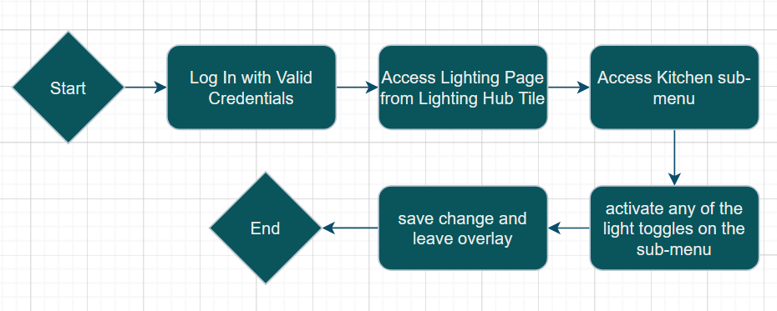

Figure 65 - User flow of Test 1

The user found the flow clear and had no errors or doubt in how to achieve the test goal.

### The Tester should attempt to change the temperature in the Study to 18°

In this test the tester had to find the temperature page, and either use the arrow keys to change the value or manually type in the new number.

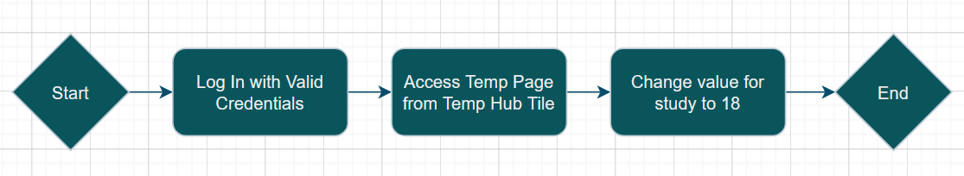

Figure 66 - User flow of Test 2

The tester found the page and value easily, but as there was no success response upon saving or leaving the page, the tester was unclear if the save was successful.

### The Tester should attempt to enable a routine

The Tester had to find the Routines page and enable any pre-existing routine.

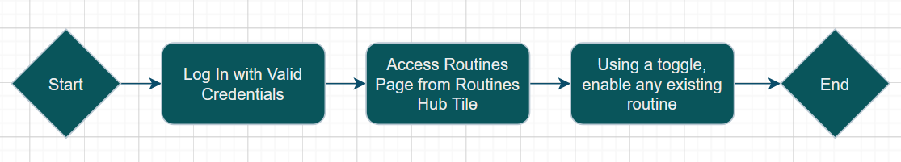

Figure 67 - User flow for Test 3

Once again as minimal process was required to reach this task, the tester found the correct page very easily and enabled a routine. However enabling a recommended routine did not add it to the user’s routines which should be considered.

### The Tester should attempt to tick off a suggestion

The Tester had to find the Your Usage page and tick off a suggested improvement.

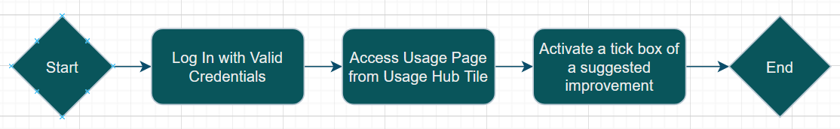

Figure 68 - User flow for Test 4

The tester found the page easily and activated a tick box with no errors, however as there was no change in the user’s goal indicator or any form of UI response the tester was uncertain if it had been done correctly.

### The Tester should attempt to activate a peripheral

The Tester had to access the connections page and activate an existing peripheral using a toggle.

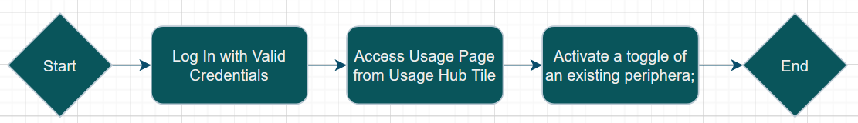

Figure 69 - User flow of Task 5

The tester once again found the page easily and activated a toggle, but as there was no success response or any indication to what the user was activating within the app, the tester did not find the change convincing.

## 4.2 – Tester Survey

### Survey Link:

<https://forms.gle/U6wvrGnVd2qKpgL49>

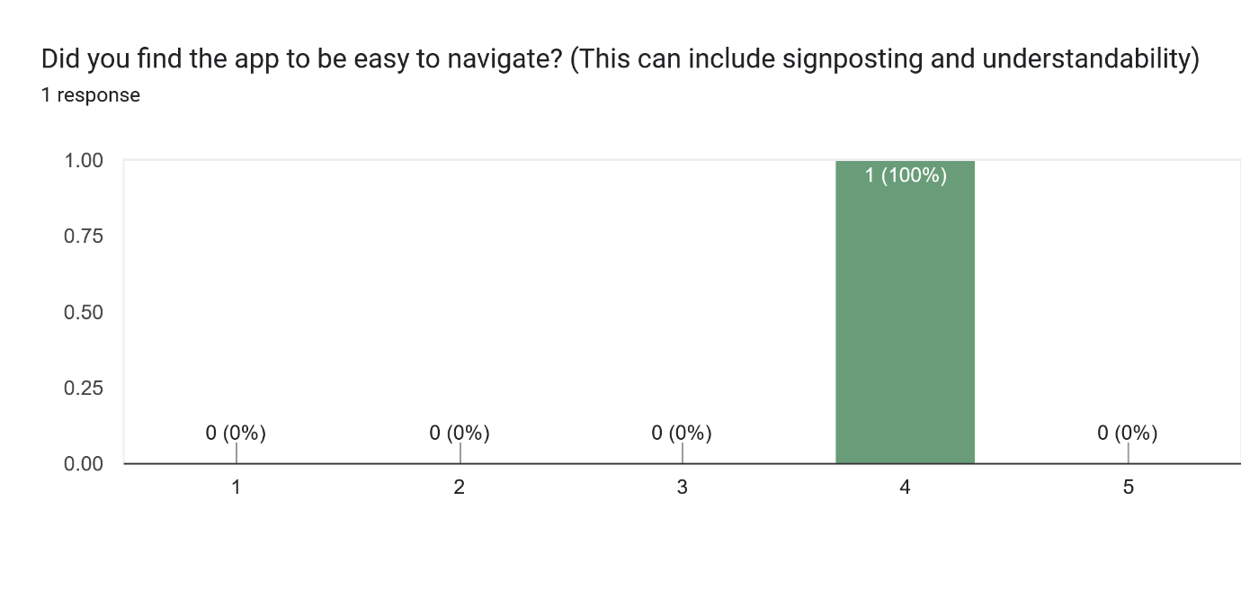

Figure 70 - Survey Response 1

The tester found the app easy to navigate given the current button names and icons.

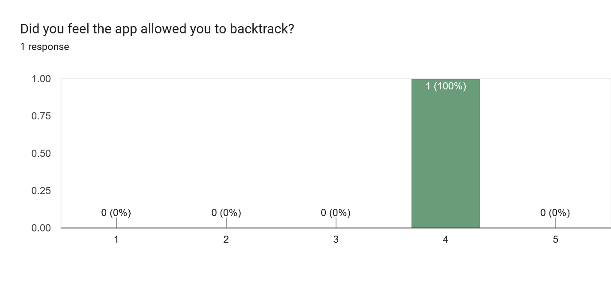

Figure 71 - Survey Response 2

The tester found the app easy to backtrack from, such as leaving a page without saving.

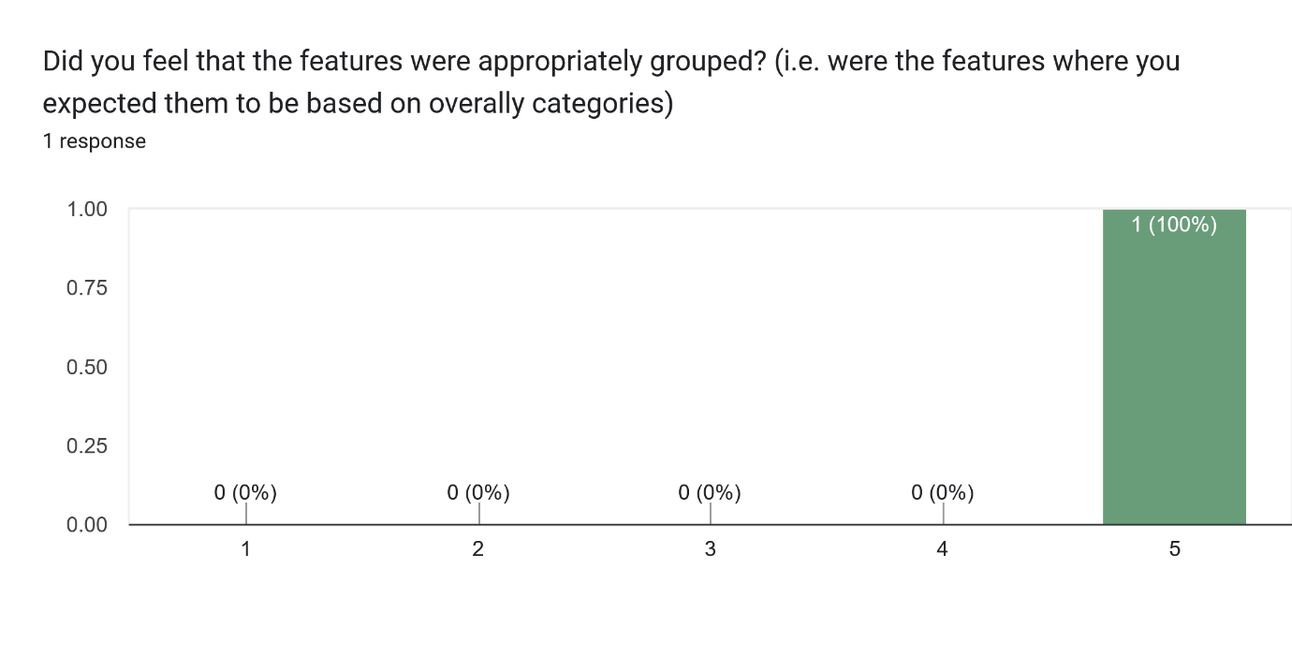

Figure 72 - Survey Response 3

The tester felt that the functions were very appropriately grouped by function, making it easy for users to find features.

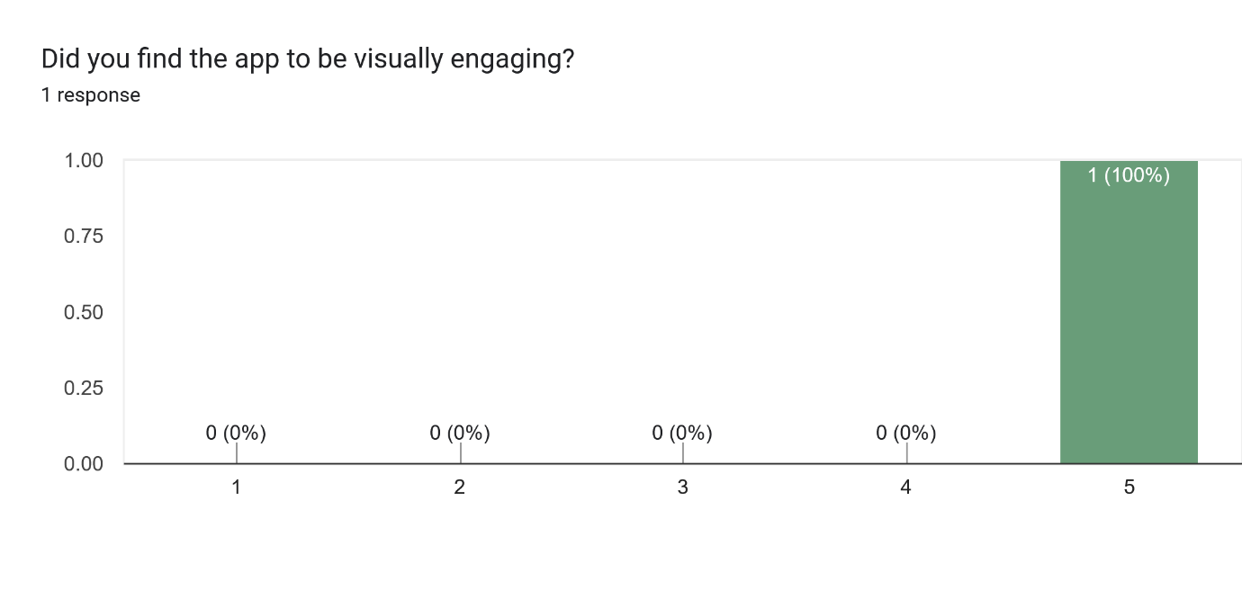

Figure 73 - Survey Response 4

The tester found the app to be very engaging, alluding to good design choices which kept users engaged.

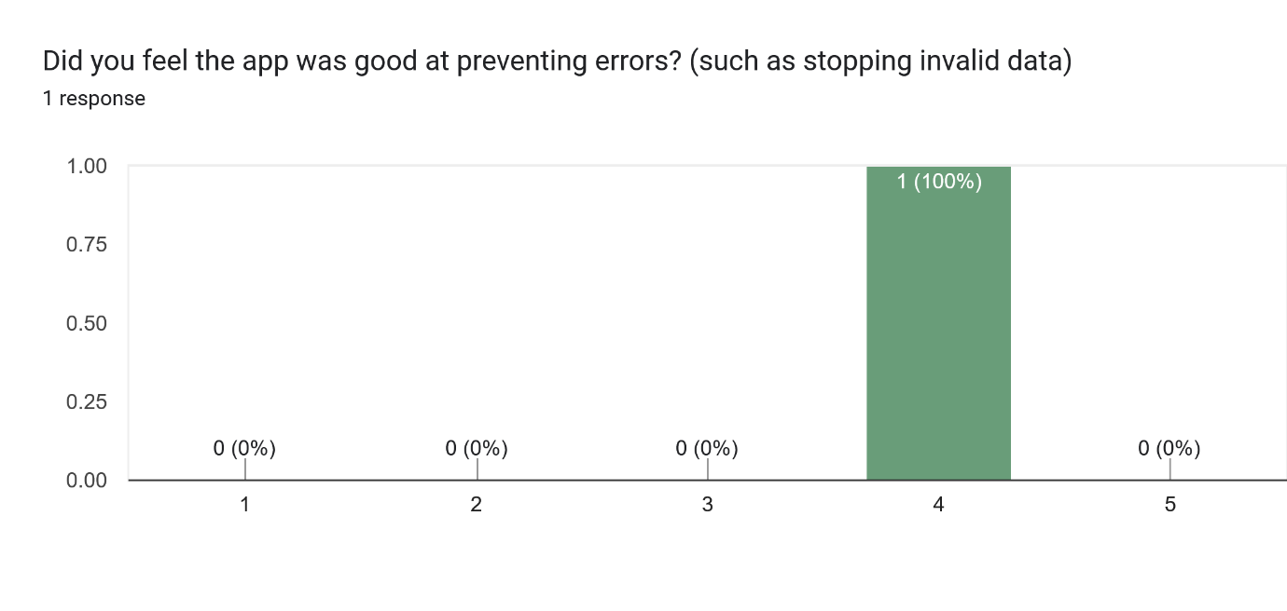

Figure 74 - Survey Response 5

The tester felt that the app was good at preventing errors but had room for improvement on preventing misinputs.

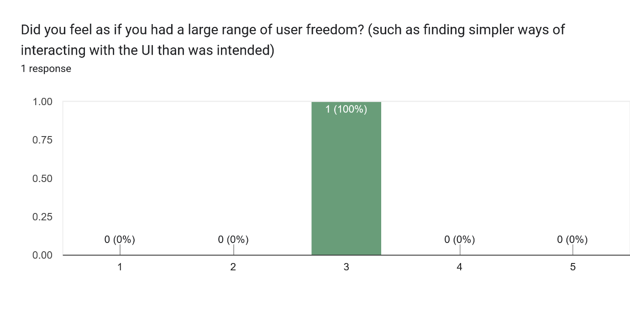

Figure 75 - Survey Response 6

The tester found that while there was some freedom in how the user interacted with the features, some improvement could be made to make the app simpler.

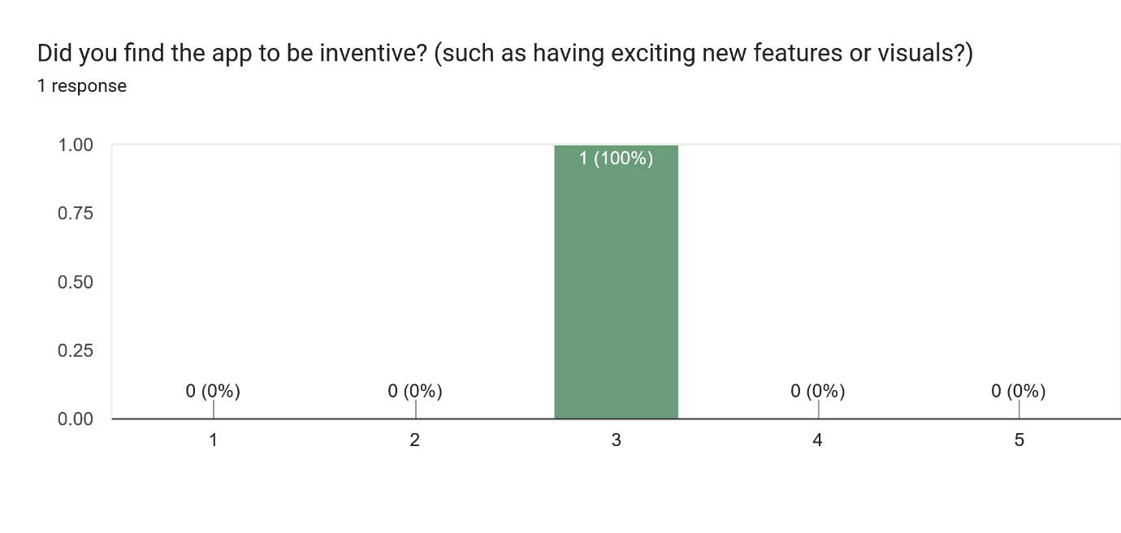

Figure 76 - Survey Response 7

The Tester found that the app had some inventive approaches to how features were implemented, there was also a consistent underlayer.

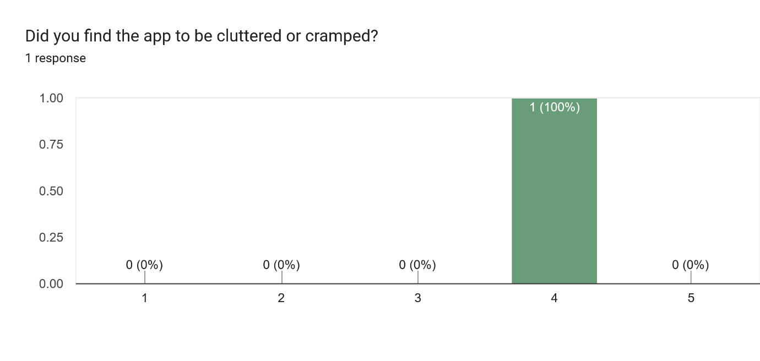

Figure 77 - Survey Response 8

The tester believed that the app was quite organised, but some pages were more cluttered than others, which could be rectified using sub-menus or additional overlays to take functions off of the main page.

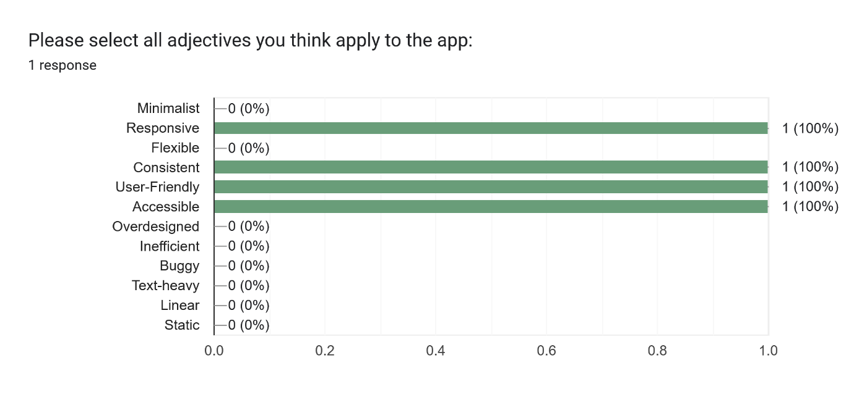

Figure 78 - Survey Response 9

The Tester believed the app was “Responsive”, “Consistent”, “User-Friendly”, and “Accessible”. The tester did not select any negative/neutral adjectives yet left out key Heuristics such as minimalism and flexibility.

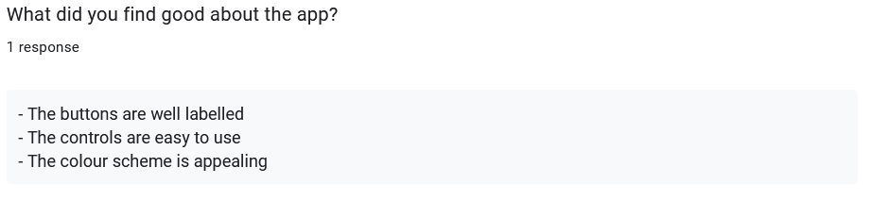

Figure 79 - Survey Response 10

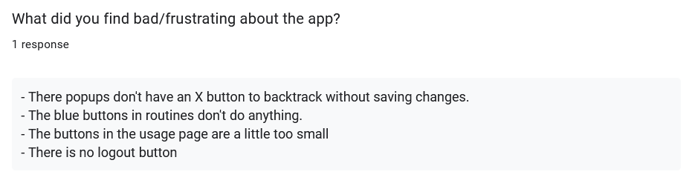

Figure 80 - Survey Response 11

These responses allowed the tester to express their opinion on the app as a whole. The tester found the app visually appealing and easy to navigate but had issues with the ability to backtrack from certain pages and found some interactable elements too small/nonfunctioning.

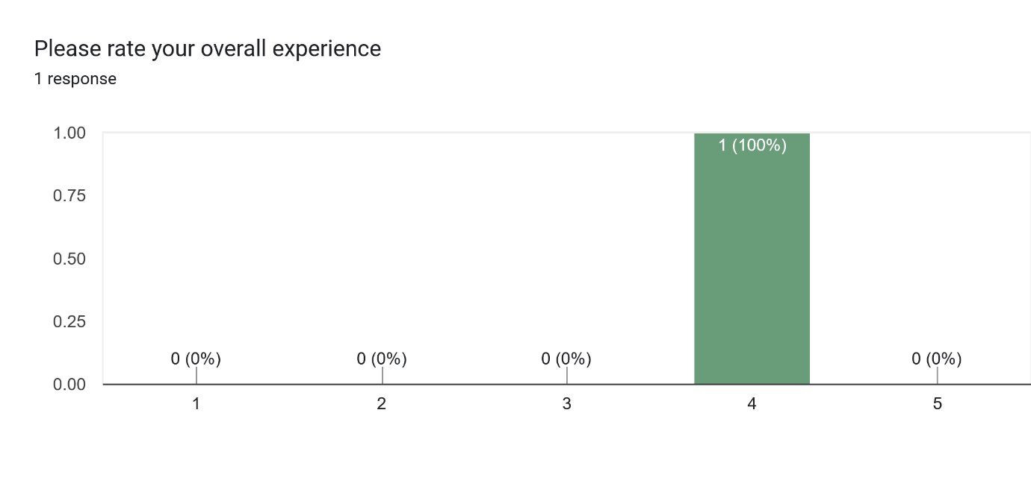



Figure 81 - Survey Response 12

Overall the tester rated the app 4/5 stars. Given the issues the tester found with the backtracking and resolution changes they still rated quite highly for the implemented features presented.

## 4.3 – Reflection

The most prevalent responses to the survey were the lack of success responses and the issue of backtracking within the app. This could easily be fixed by adding a log-out button to the main menu and adding alerts to set actions such as changing values and saving changes. The user feedback also highlighted that while the app was well organised in the preferred resolution, it was far less structured in the standard resolution. This would require more refactoring of the margins in the style sheets. The user has minimal issue with the functionality of each page barring the toggles on the add routine overlay, and the tick boxes on the usage page as they were too small. While the tick boxes can be changed quite easily, the add routine overlay would need more attention as creating functionality for adding each light/room/temperature/time would require several sub-menus as well as JavaScript functionality.

# Bibliography

*Don Norman’s Principles of Interaction Design | by Sachin Rekhi | Medium* (2017). <https://medium.com/@sachinrekhi/don-normans-principles-of-interaction-design-51025a2c0f33> [Accessed 15 Apr 2025].

Gonzalez-Holland, E., Whitmer, D., Moralez, L. & Mouloua, M. (2017) Examination of the Use of Nielsen’s 10 Usability Heuristics & Outlooks for the Future. *Proceedings of the Human Factors and Ergonomics Society Annual Meeting*, 61(1), p. 1472–1475. Available online: <https://doi.org/10.1177/1541931213601853>.

Green Color Psychology, Symbolism and Meaning (2015), 22 February. <https://www.colorpsychology.org/green/> [Accessed 24Mar 2025].

*How the Color Blue Impacts Moods, Feelings, and Behaviors* (2024) *Verywell Mind*. <https://www.verywellmind.com/the-color-psychology-of-blue-2795815> [Accessed 21 Apr 2025].

Machado Neto, O. & Pimentel, M.D.G. (2013) Heuristics for the assessment of interfaces of mobile devices. In *Proceedings of the 19th Brazilian Symposium on Multimedia and the Web*. *WebMedia ’13: 19th Brazilian Symposium on Multimedia and the Web*, ACM, p. 93–96. Available online: <https://doi.org/10.1145/2526188.2526237>.

Nielsen, J. (1994) Enhancing the explanatory power of usability heuristics. In *Proceedings of the SIGCHI Conference on Human Factors in Computing Systems*. *CHI94: ACM Conference on Human Factors in Computer Systems*, ACM, p. 152–158. Available online: <https://doi.org/10.1145/191666.191729>.